|  |
| --- |
| Google Analytics Campaign and Revenue Analysis  Period 2016 - 2018 |
| **pure minds**  Jan Campertstraat 7  6416 SG Heerlen  The Netherlands  045 369 0530 info@pureminds.nl |



**Table of Contents**

Our team 3

Executive Summary 4

Overview 5

Executive Dashboard 5

Discussion 8

Campaign Analysis 8

Long-term Impact of Campaigns 11

Site Usage 16

Revenue Prediction 19

Bibliography 21

Appendix 22

Tableau 22

SPSS Modeler 44

Additional Tableau Figures 52

## Our team

|  |  |
| --- | --- |
| https://lh5.googleusercontent.com/bTXGV6xS-6qXe9mS2VqWg_wfxPLHSgKIjWkIMm0g7m4gl8m9RRUGQKvNbcI74vXiHdan-pKvdOUHNLSPVgjQpQoCQyB8ZP0LlKLznSQgjRrCY3vTRGB0UZ5HzilwyDDg4CS4w4z7 | **Tran To Anh**  ***School of Business and Economics***  ***Maastricht University***  toanh260196@gmail.com  +31 62 010 8385 |
| https://lh3.googleusercontent.com/z5Wqi0DchF_C4hhQJnm_xGBjfSrpw6Zpv0Ho413aQ2LZH9mjNSEakqH5axnV-XGPJBf8eyiOwvf799X_gmxTRWPInKt6TwuyRS0N5sGB60VLsFJqZw2TQ9VsCCS5t_YjPTFLzTIh | **Stephen McCarthy**  ***University College Maastricht***  ***Maastricht University***  iamstephen.mccarthy@gmail.com  +31 64 628 2070 |
| https://lh3.googleusercontent.com/ZvFYr0jc4caihLda25fPtNZDv8Wtj-7cRFR4teo8AauRlkzp5DerJ70W5Ym1Xnssc7msW58CvFdR2yKZUR2uI1Y2hHPJldITszT8AYSEdmVzuDV5PgKh7IlaKGB-cXZHKLDYtGHD | **Linda Amaduzzi**  ***University College Maastricht***  ***Maastricht University***  linda.amaduzzi@gmail.com  +39 34 905 00953 |

## Executive Summary

**Objectives:**

* Develop a model to predict the revenue of Kantoorartikelen.nl.
* Assess the long-term value/impact of their marketing campaigns.

**Results:**

We present a revenue prediction model (pages 19-20) and provide two models for assessing long-term impact of the variable campaigns (pages 11-15).

The revenue prediction model we suggest, the Generalized Linear model, is the most accurate out of those we tested and can be seen on page 20.

The first long-term impact assessment model, the Distributed Lag Model, is an advanced experimental model gaining traction that we believe Kantoorartikelen should consider as an investment.

The second long-term impact assessment model, the Neural Network Model, is reasonably accurate and worth pursuing.

## Overview

Pure Minds is a result-driven online marketing agency that utilizes advanced data analytics tools and platforms to identify potential aspects in their marketing and operational strategies that bring about successful results, and then capitalize on them. One such platform is Google Analytics, which is a freemium web analytics service offered by Google that tracks and reports website traffic.[1]

Understanding the company priorities and framework, we have drawn up several dashboards based on the Google Analytics traffic data of **kantoorartikelen.nl**, the website of interest. The time frame of the data is January 1, 2016 – April 30, 2018.

In this section, an overview dashboard, called the ‘Executive Dashboard’, which captures the big picture regarding the revenue and transactions on the website, will be presented.

### Executive Dashboard

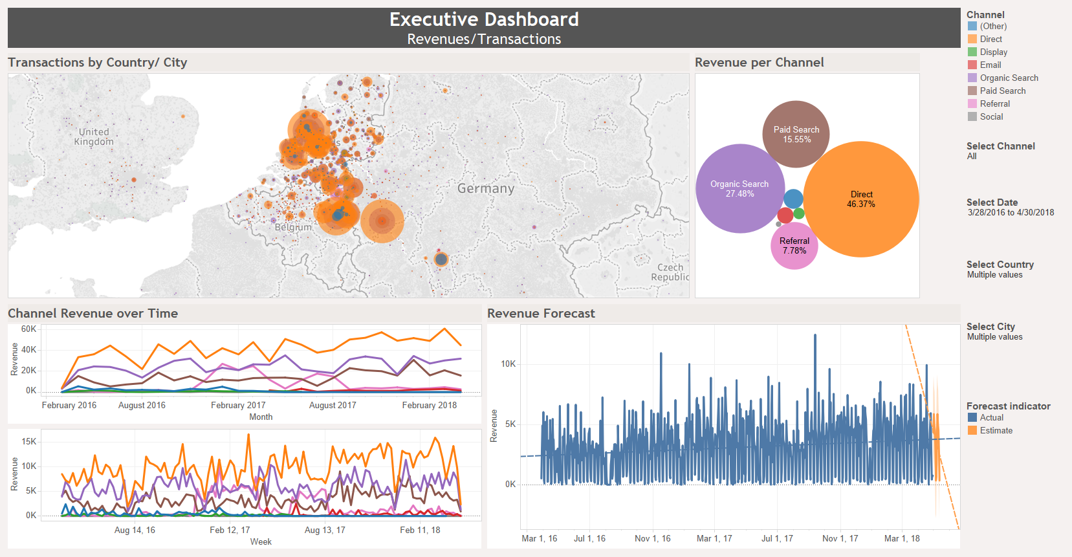

Figure 1 Executive Dashboard.

From the Executive Dashboard (Figure 1), it is evident that most of the transaction revenue of Kantoorartikelen comes from Europe, particularly The Netherlands. Several cities in The Netherlands stand out from the dashboard, as they contribute to a remarkable proportion of the website revenue. Some such cities are Amsterdam, De Bilt, Rotterdam, Maastricht and Heerlen. This observation makes intuitive sense, as the webshop is based in the Netherlands. In addition, revenue also comes from part of Germany, such as Bornheim.

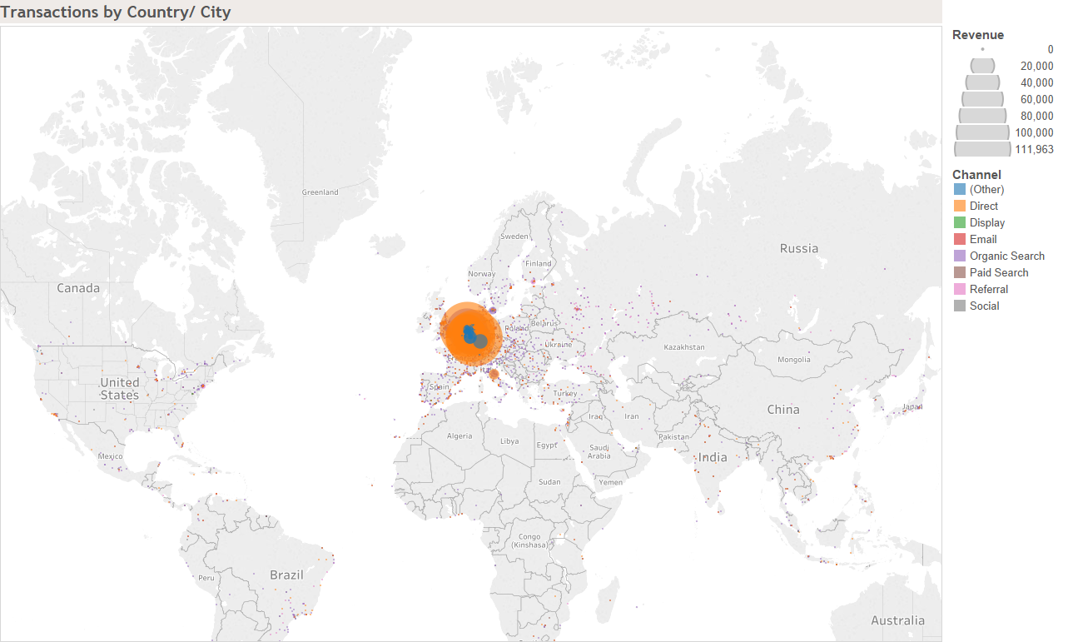

Figure 2 Transactions by Country

To further validate our first impression that a bulk of Kantoorartikelen’s revenue originates from Europe, we examine the online transactions and revenue per country (Figure 2). According to the map, most revenue indeed comes from Europe. In light of this consideration, it can be suggested that Kantoorartikelen’s focus should be the buyers in Europe, especially large cities in The Netherlands.

Returning to Figure 1, we can draw additional conclusions about the most profitable channels, as well as the evolution of the website revenue over time. For example, the top 2 channels that have yielded the highest revenue are direct[2] and organic search[3]. From the timeseries charts, an increasing trend in the revenue from said channels can also be observed, albeit there are many fluctuations when the monthly revenue is under visual scrunity. That the orange timeseries line lies above all other lines indicates that direct traffic indeed dominates all other channels. While this seemingly lends credence to the fact that the direct traffic of the website ought to be examined further, we should be mindful that data from any number of sources could end up in the Direct bucket.[4] As such, in the case of possibly miscategorized data, Kantoorartikelen may have received more organic search traffic than Google Analytics shows.

The final revenue forecast suggests a downward trend in the May 2018 revenue. However, this should be taken with a pinch of salt, and further analysis is called for, as the (somewhat periodic) fluctuations of the daily revenue renders the linear forecast less reliable as a revenue prediction model, compared to other types of forecast. Further analyses will be discussed in details in the next sections.

## Discussion

Taking a step further than just examining the big picture, i.e understanding overall revenue trends, we have dived into different segmentations of Google Analytics revenue data.

### Campaign Analysis

The following Campaign Analysis captures the most important information about the performance of current marketing campaigns employed by the client, the variation in campaign revenues, as well as the performance of top campaigns (Figure 3).

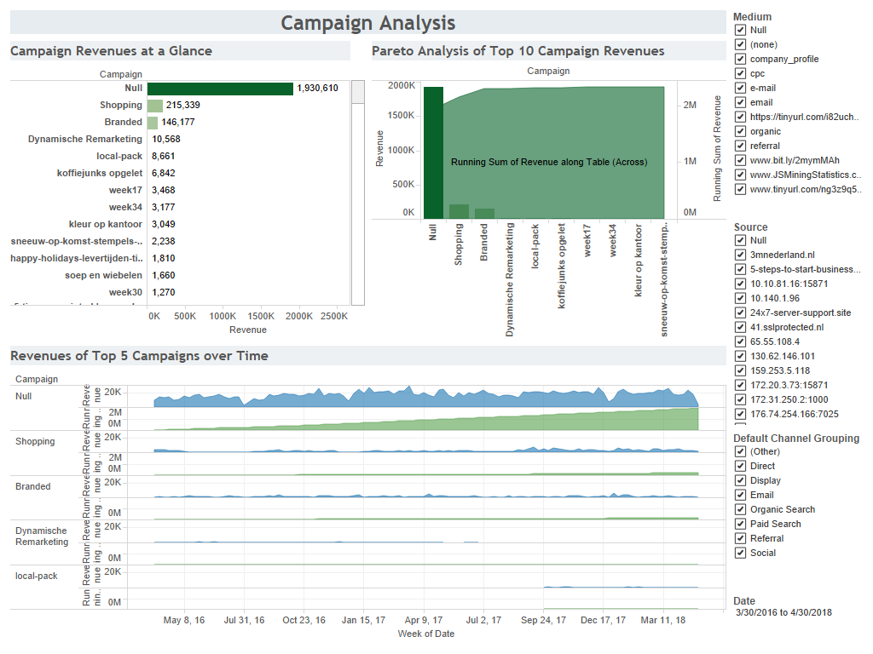

Figure 3 Campaign Analysis Dashboard

According to the figure above, the so-called ‘top’ campaign, which dominates all other marketing campaigns so far, is in fact the ‘null’ campaign (Revenue $\sim$ 2 mil EUR); in other words, having no campaigns at all seems to have the most impact on the transaction revenue on the website. The total revenue generated by the second and third most profitable campaigns, ‘Shopping’ and ‘Branded’, still pale in comparison to the revenue yielded by the ‘null’ campaign. Those two campaigns and ‘null’ (no campaign) make up about 80% of the revenue. Although this might give rise to a counter-intuitive suggestion that running no campaigns at all is better for the business overall, it is also worthwhile to examine the quality of the campaign data. The ‘null’ campaigns might as well be a result of a failure to categorize campaigns.

The Pareto chart serves to confirm the previous finding. Pareto Analysis is a statistical technique in decision-making used for the selection of a limited number of tasks that produce significant overall effect, based on the Pareto Principle.[5] In our case, the Pareto chart indicates the top campaigns that contribute the most to the overall revenue of Kantoorartikelen. It is evident that the ‘null’ campaign dominates all other campaigns, making up the largest fraction of the cumulative revenue.

In the timeseries charts, we see that there is some variation in the weekly revenue of the ‘null’ campaign. There are some dips in the weekly revenue, particularly in July 2016, January 2017, and January 2018. This indicates a possible seasonal trend, which can also be observed in the data for other campaigns. The blue area denotes the total revenue of a campaign, while the green area indicates the running sum of the revenue of the said campaign.

Therefore, not considering the ‘null’ campaign, and instead examining the top 5 performing campaigns in the chart below (Figure 4), we can see that the revenues of these campaigns increased from September 2017 onwards. Not only did the running sum of revenue increase (which is a given by the way it is defined), but the individual impact of every campaign also increased.

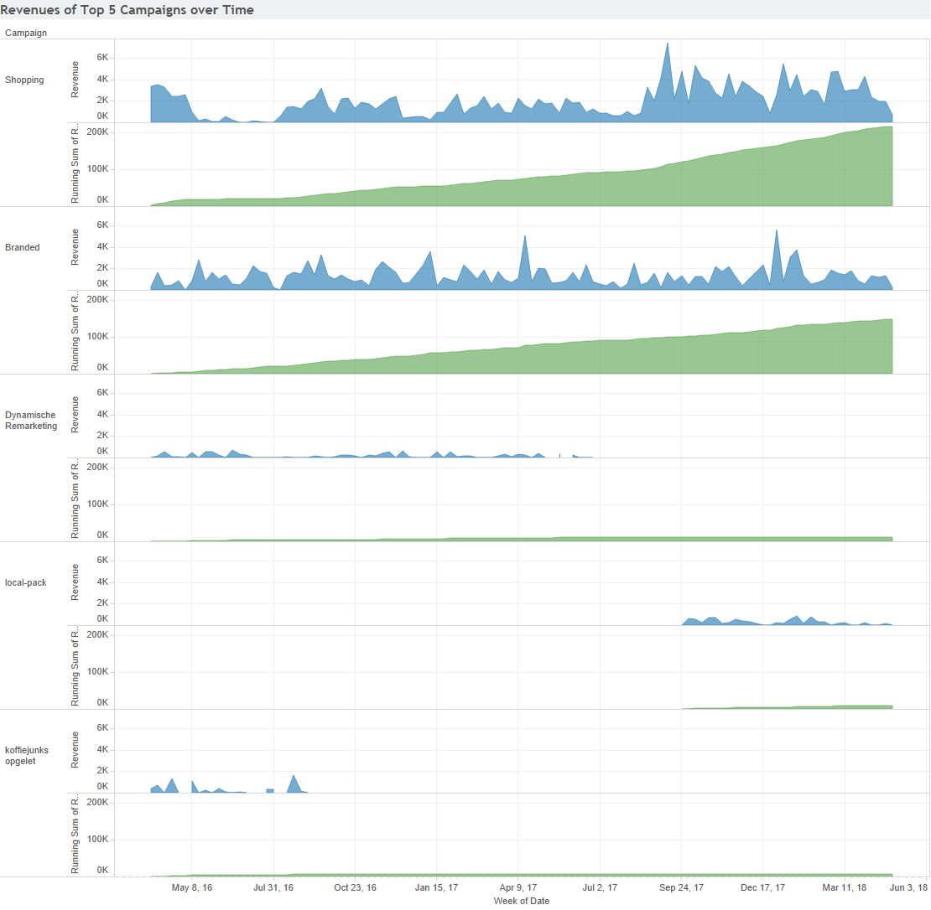

Figure 4 Revenues of Top 5 Campaigns

We will further evaluate the long-term impact of the campaigns on the next page.

### Long-term Impact of Campaigns

Google Analytics allows investors to track their return on investment (ROI) on every launch, funnel, email, and ad campaign. A relevant point of concern arises: What types of campaigns (or, if possible, which campaign) matter the most in the long run?

Thus, our team recognizes two possible methods of measuring the long-term impact of advertising campaigns. The first is the Distributive Lag Model (DLM), and the second is the Neural Network/ Classification & Regression Tree (C&RT) Model.

#### Distributed Lag Model

Timeseries marketing models often involve an element of distributed lag, especially in terms of the relationship between sales and advertising.[6] In statistics and econometrics, a distributed lag model, for timeseries data, consists of a regression equation which is used to predict current values of a dependent variable (in our case, the transaction revenue) based on both the current values of an explanatory variable (i.e campaign revenue) and the lagged (past period) values of said explanatory variable.[7]

While the Distributive Lag Model has been making strides in academia in the field of Econometrics with major appearances in recent journals[8], the theory behind it is beyond the scope of this report, as well as highly experimental. Nonetheless, as Dhalla suggested in Havard Business Review, to improve business results, advertising must be viewed as a capital investment, with revenue generated like a stream over time, by assessing the customer-holdover or cumulative effect of campaigns.[9] Our team believes that this advanced model is worth pursuing by the statistics department of Kantoorartikelen.

#### Neural Network/ Classification & Regression Tree (C&RT) Model

Neural networks are simple models inspired by the way the nervous system operates. The basic units in neural networks are **neurons** typically organized into **layers**. Neural networks improve their performance by repeatedly finetuning their predictions at every neuron, until one or more stopping criteria have been met.[10] Artificial neural networks are likely to outperform traditional predictive models, especially when data with complicated relationships is concerned.[11]

The neural network model, hereinafter NNM, can be utilized to the effects of advertising campaigns on transaction revenue. Due to insufficient variables in the Google Analytics data, we will demonstrate an application of the model using fictitious data.[12]

Our fictitious data consists of 5 variables:

* **Product type:** product category (e.g drink, confectionary, etc.)
* **Cost:** unit price.
* **Campaign:** index of amount spent on a particular campaign.
* **Before:** revenue before campaign.
* **After:** revenue after campaign.

An overview of the data is as follows:

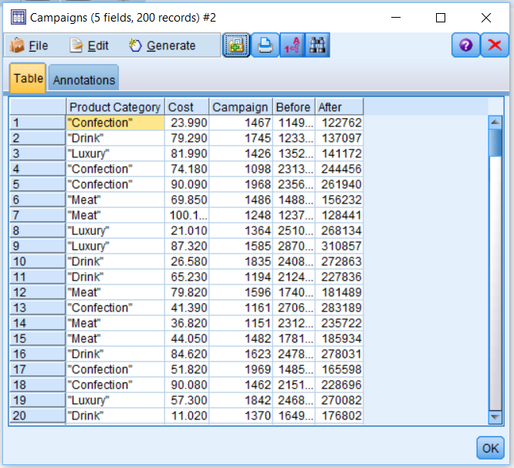

Figure 5 Fictitious ads campaign and product data

It is of more interest to us to calculate the increase in revenue after each campaign.

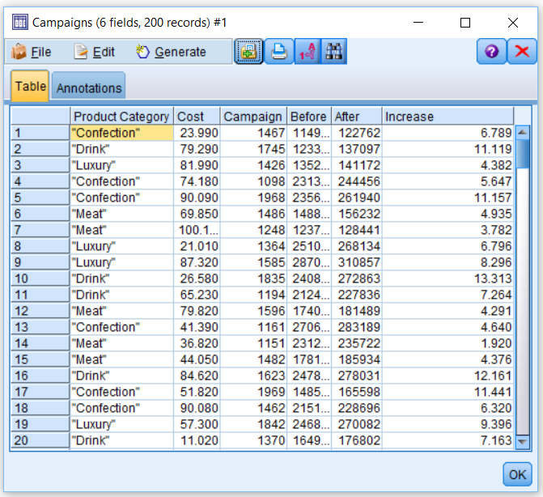

Figure 6 Revenue increases after campaigns

A graphical representation of the revenue increases are as follows:

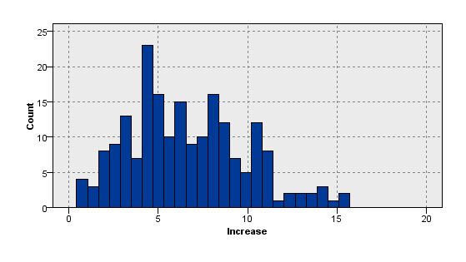

Figure 7 Histogram of revenue increases

Figure 8 shows that, for each product category, an almost linear relationship exists between the increase in revenue and the cost of the associated campaign. Therefore, it seems likely that an NNM could predict, with reasonable accuracy, the increase in revenue using the other available variables as features.

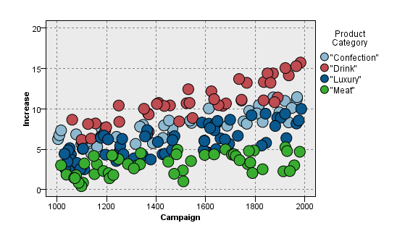

Figure 8 Scatterplot of Revenue increases VS Campaign Cost

After running the NNM, our team observed that the accuracy of the model is 86% (Figure 9). Hence, this model could potentially appeal to the management team at Kantoorartikelen as a possible way to assess the long-term impact of their Google Analytics campaigns.

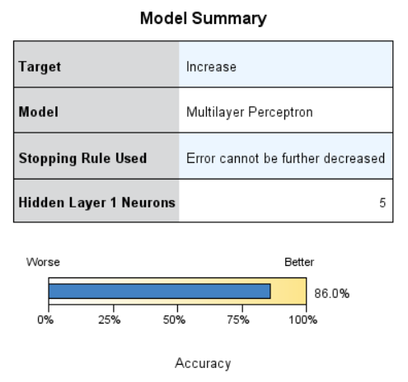

Figure 9 Accuracy of NNM

### Site Usage

The following Site Usage Dashboard shows aspects of website traffic that might be relevant to website content managers of Kantoorartikelen.

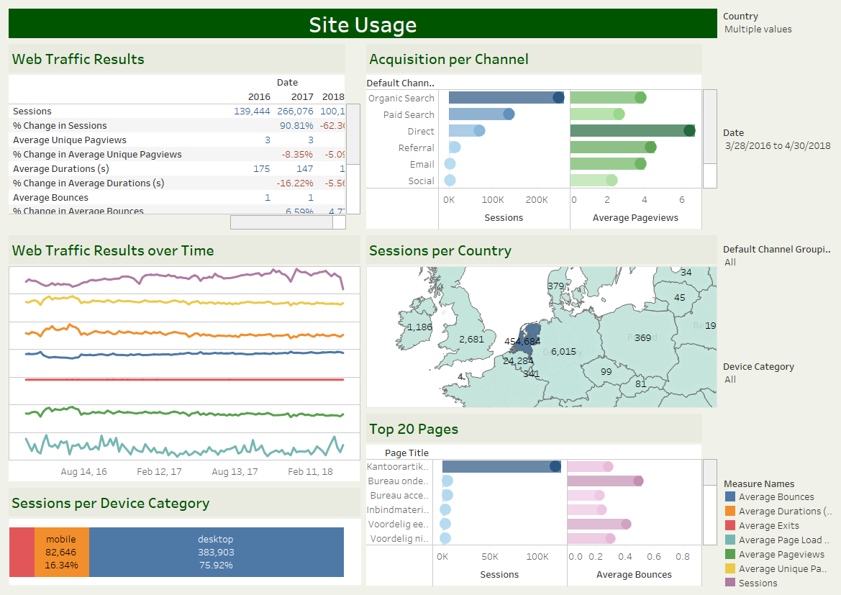

Figure 10 Site usage Dashboard

Most of the traffic is from the Netherlands. After looking at the site, we noticed there was no translation options for other languages. Providing English, German, and French options would likely increase revenue from non-Dutch sources.

The top 20 pages, ranked by the total number of sessions and the average number of bounces per page, are as follows:

1. Kantoorartikelen.nl is dé kantoorspullen webshop van Nederland
2. Bureau onderleggers koopt u bij Kantoorartikelen.nl
3. Bureau accessoires koopt u online bij Kantoorartikelen.nl
4. Inbindmaterialen koopt u voordelig bij Kantoorartikelen.nl
5. Voordelig een perforator kopen bij Kantoorartikelen.nl
6. Voordelig nietmachines kopen bij Kantoorartikelen.nl
7. Voordelig tabbladen kopen bij Kantoorartikelen.nl
8. Kaartenbakken en toebehoren koopt u bij Kantoorartikelen.nl
9. Insteekmappen koopt u voordelig bij Kantoorartikelen.nl
10. Voordelig dossiermappen kopen bij Kantoorartikelen.nl
11. Hoe bestel ik de juiste hangmap - Kantoorartikelen.nl
12. Lamineren, koud of warm - Kantoorartikelen.nl
13. Diverse brievenbakjes koopt u bij Kantoorartikelen.nl
14. Pennenbakjes en bureau organisers bij Kantoorartikelen.nl
15. Voorbedrukte bedrijfsformulieren bij Kantoorartikelen.nl
16. Ringbanden en ordners koopt u bij Kantoorartikelen.nl
17. De beste kleur op kantoor - Kantoorartikelen.nl
18. Hoe ver moet ik van mijn beeldscherm af zitten - Kantoorartikelen.nl
19. Whiteboard of magneetbord kopen bij Kantoorartikelen.nl
20. Kantoorartikelen.nl - Alles voor uw Kantoor

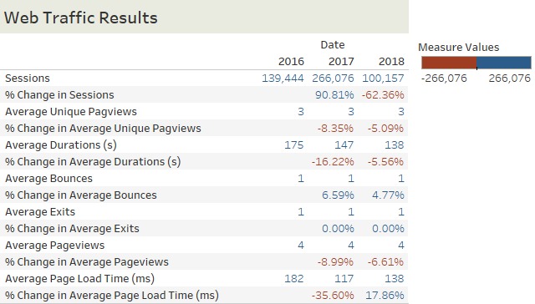

Figure 11 Web Traffic Results

Don’t be alarmed by the -62.36% change in sessions in 2018 in *Figure 11*, as the measurement was made only half-way through the year. We also see that average session time is trending downward. This could indicate that customer attention spans are shortening or perhaps that the pages themselves are clear enough that the customer can decide quicker.

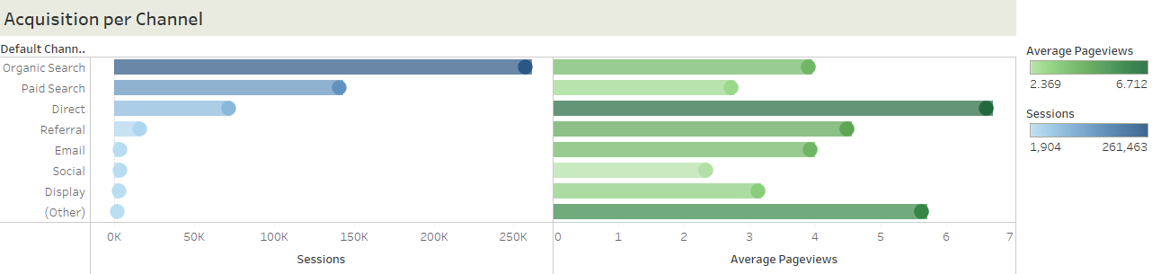

Figure 12 Acquisition per Channel

We can see in Figure 12that Organic Search has the most sessions, yet Direct has the highest Average Pageviews. This might be because users that directly visit the site with a goal, compared to users arriving from a search engine, are there to shop around while users from a search engine search for a specific product.

### Revenue Prediction

One major task assigned to our team is to develop a prediction model for the revenue of Kantoorartikelen. Although the overall revenue prediction can be seen previously in the Executive Dashboard, in this section, we demonstrate several other prediction models that are more advanced than simple linear regression models.

It is important to note that there are 2 revenue categories that can be chosen to predict: product revenue, and transaction revenue. With the use of SPSS Modeler, we filtered out redundant Google Analytics variables, leaving only those that are most relevant to our analysis.

#### Product Revenue Prediction

In predicting the revenue of a product from the purchase quantity and the total number of users per time period, we employed 3 models: Classification & Regression (C&R) Tree, Neural Net, and Linear Regression. The performance of the different models can be seen in the following figure:

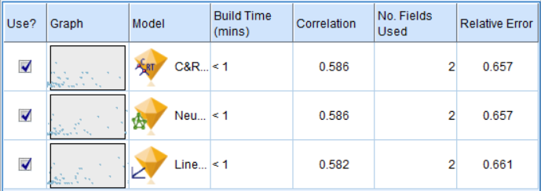

Figure 13 Product Revenue Prediction

C&R Tree and Neural Net seem to perform better than the traditional linear model, as they have the lowest relative error, and thus are worth pursuing.

#### Transaction Revenue Prediction

In predicting the overall transaction revenue from the number of transactions, device category, gender, source, channel, and the number of sessions, we employed 3 models: Generalized Linear, Classification & Regression (C&R) Tree, and Neural Net. The performance of the different models can be seen in the following figure:

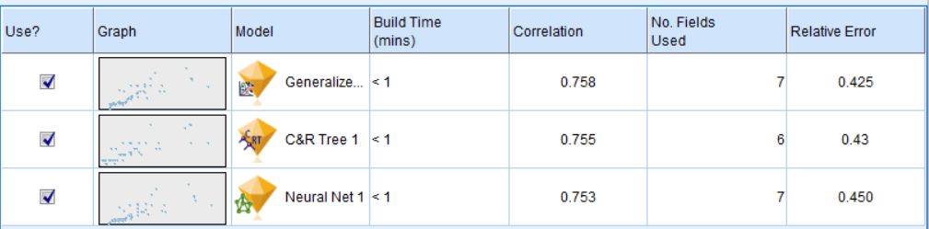

Figure 14 Transaction Revenue Prediction

Generalized Linear seems to perform better than the rest, as it has the lowest relative error, and thus is worth pursuing.

## Bibliography

Google Analytics. (2018, May 28). Retrieved May 30, 2018, from <https://en.wikipedia.org/wiki/Google_Analytics>

Megalytic.com. (2015). Understanding Direct Traffic in Google Analytics | Megalytic Blog. [online] Retrieved May 30, 2018, from <https://megalytic.com/blog/understanding-direct-traffic-in-google-analytics>.

Haughey, D. (2018). Pareto Analysis Step by Step. [online] Project Smart. Available at: <https://www.projectsmart.co.uk/pareto-analysis-step-by-step.php> [Accessed 30 May 2018].

Bass, F. M., & Clarke, D. G. (1972). Testing distributed lag models of advertising effect. Journal of Marketing Research, 298-308.

Distributed lag. (2018, March 04). Retrieved May 30, 2018, from <https://en.wikipedia.org/wiki/Distributed_lag>

Dhalla, N. K. (1978). ASSESSING LONG-TERM VALUE OF ADVERTISING. Harvard Business Review, 56(1), 87-95.

IBM Knowledge Center. (n.d.). Retrieved May 30, 2018, from <https://www.ibm.com/support/knowledgecenter/de/SS3RA7_15.0.0/com.ibm.spss.modeler.help/neuralnet_model.htm>

Burke, H. B., Rosen, D. B., & Goodman, P. H. (1995). Comparing the prediction accuracy of artificial neural networks and other statistical models for breast cancer survival. In Advances in neural information processing systems (pp. 1063-1067).

## Appendix

### Tableau

#### Connecting to Google Analytics

* Open Tableau.
* Click on Google Analytics in the Connect pane.

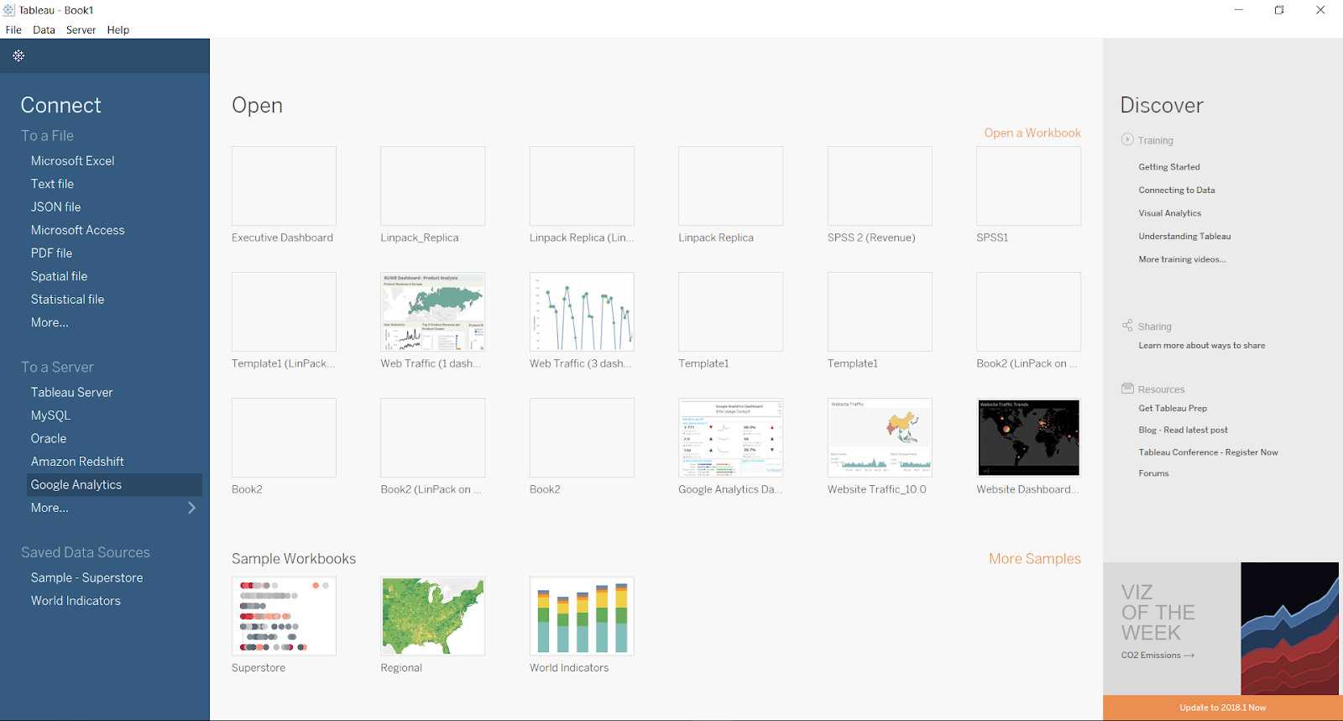

* An authentication window will pop up in your browser. Click on the ‘Big Data’ Google account.



* Click on ‘Allow’ to give consent to data usage.



* Close the popup window once this message appears, and return to Tableau.



* We arrive at the main Data Source page.

Specify Account, Property, and View as shown in the screenshot. The other options vary, according to the type of dashboard to be created.

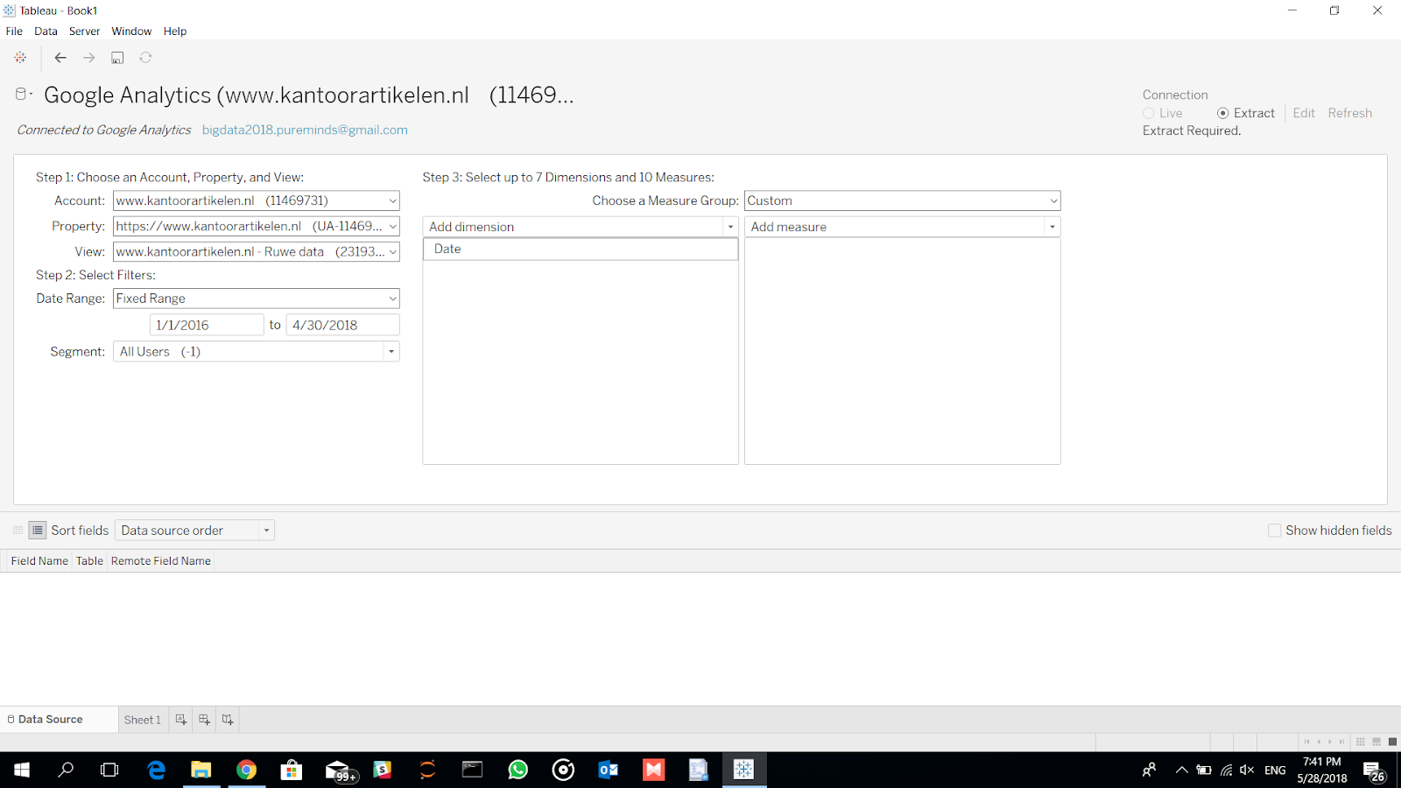

#### Executive Dashboard

* From the previous Data Source window, first save the Tableau Workbook as a Tableau Packaged Workbook (.twbx).

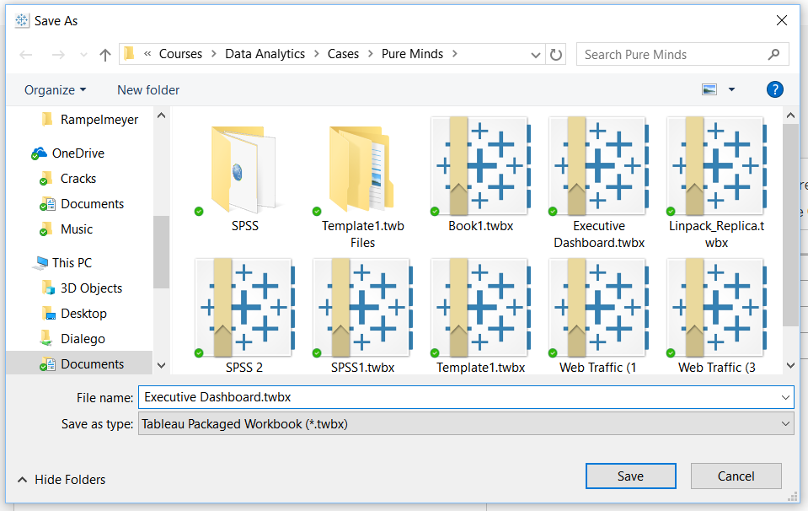

* Select the following dimensions and metrics.

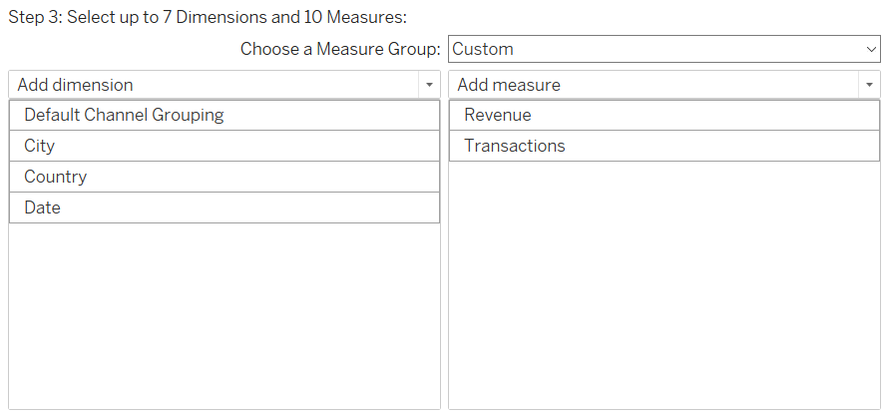

* Click on ‘Sheet 1’ to start the data extraction process in Tableau.

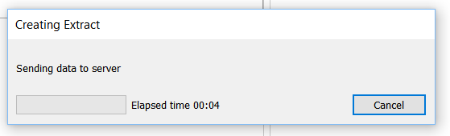

* Once the extract is created, we will be on the first worksheet.

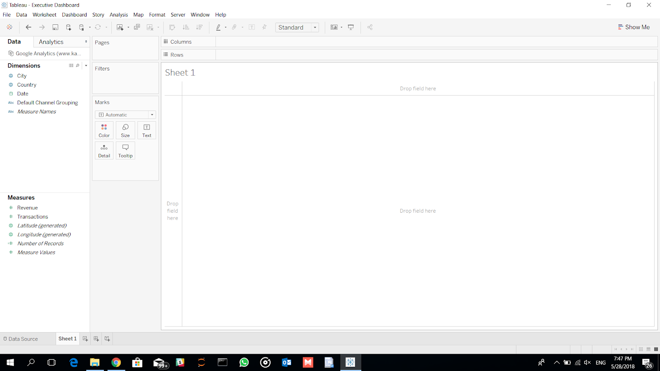

* Optional: Export the extracted data to CSV.

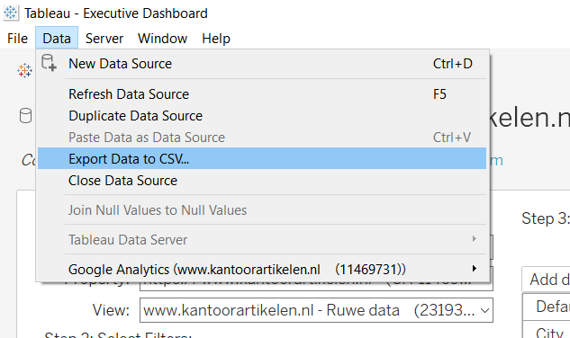

* Close the current Packaged Workbook. Create a new Tableau Workbook, and import the CSV data that has just been exported.

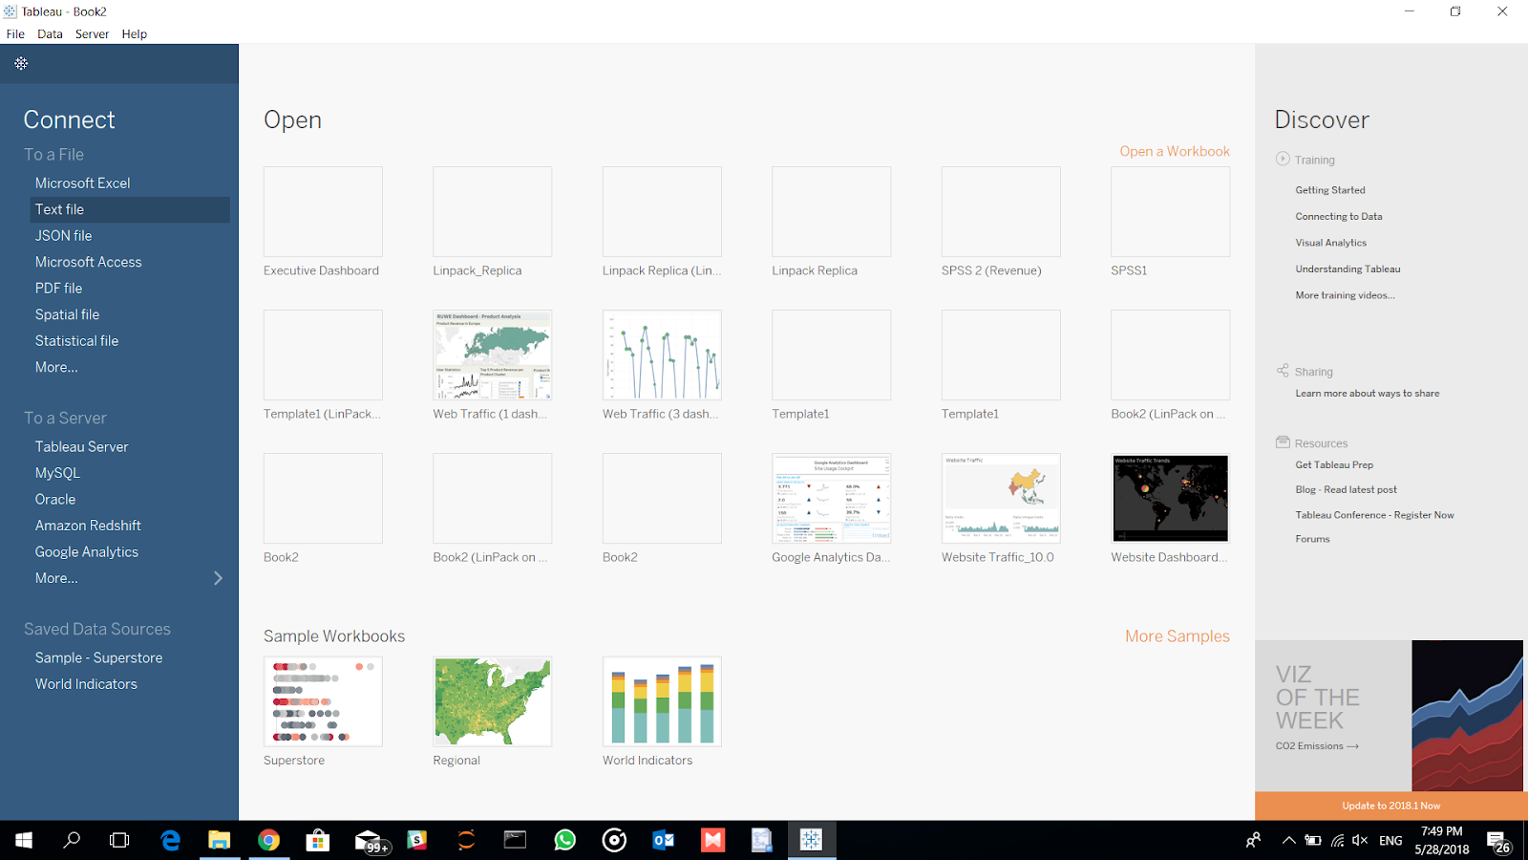

* We can see an overview of the data in the Data Source page.

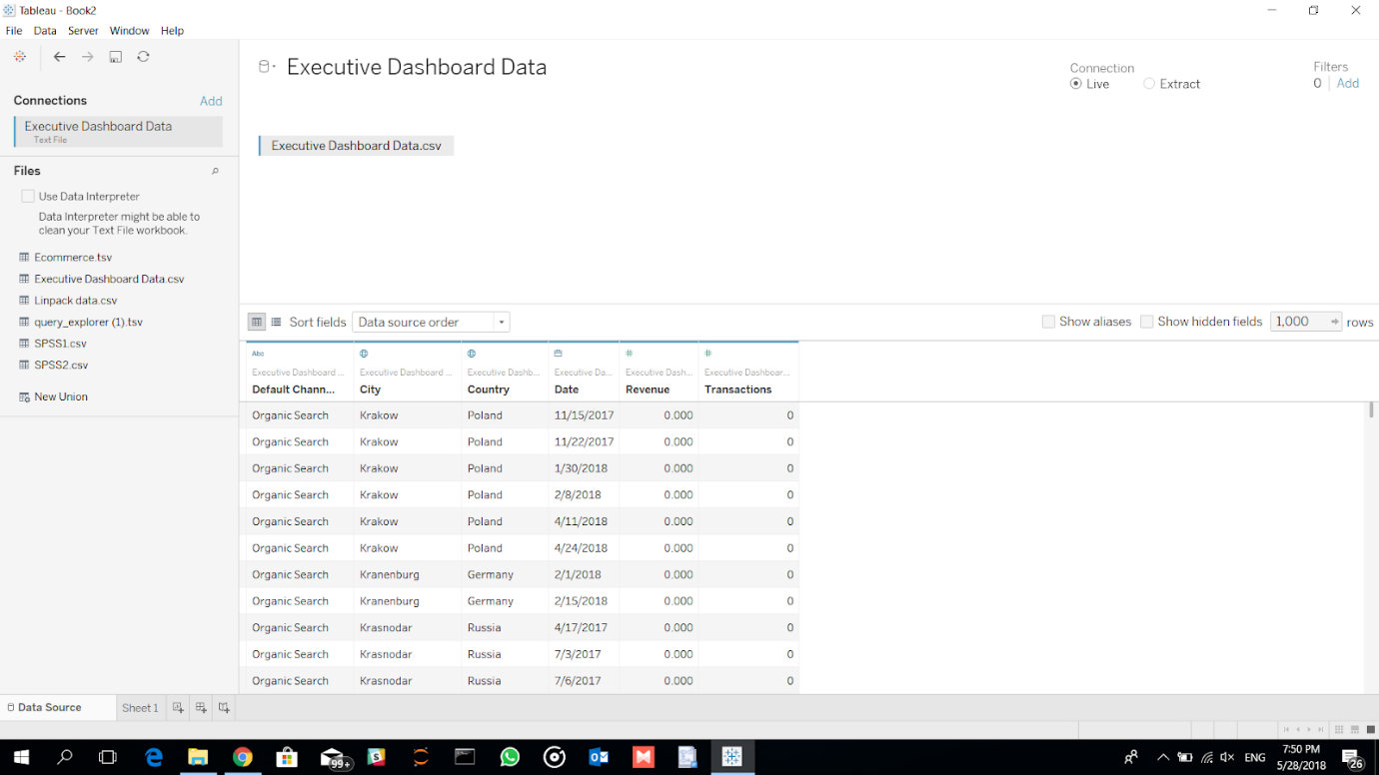

(The steps so far, from here on, will be referred to collectively as the ‘Google Analytics Data Extraction’ stage. The only difference is the combination of dimensions and measures to be extracted from Google Analytics, depending on the dashboard to be created.)

* Create a new dashboard.

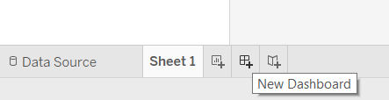

* Specify the size of the dashboard as ‘Automatic’ under ‘Size’.

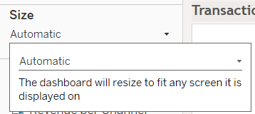

* Format the dashboard.

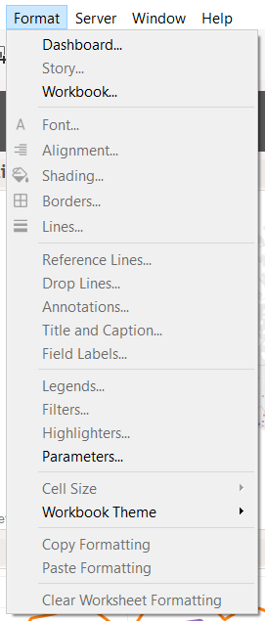

* Show the dashboard title.

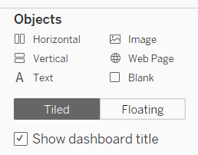

* **First worksheet:** Transaction by Country/ City

Drag the dimensions & measures as follows.

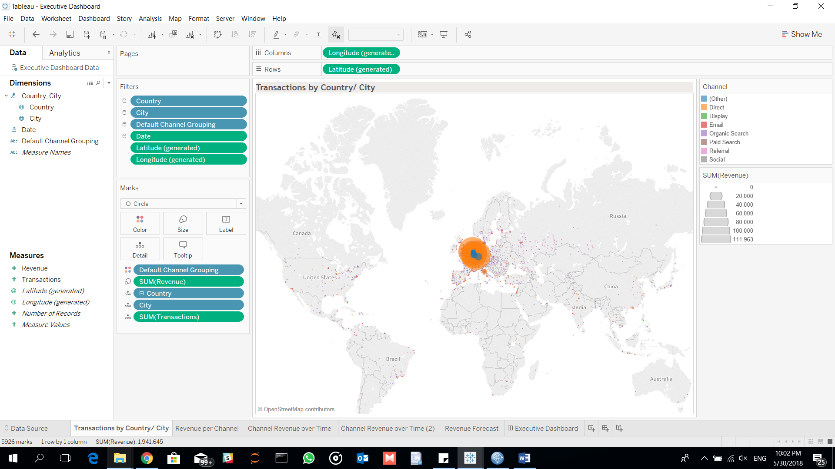

* Set global filters:

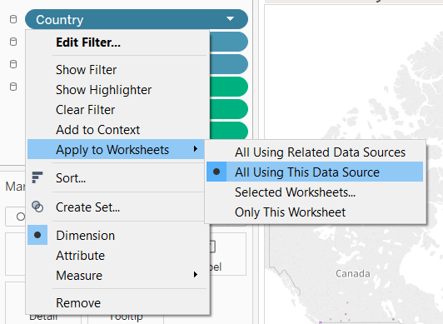

* Colors:

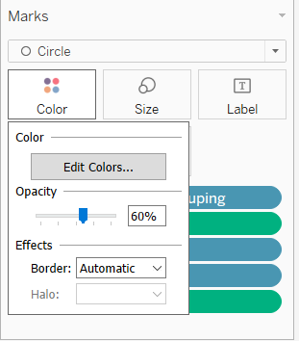

* Bubble size:

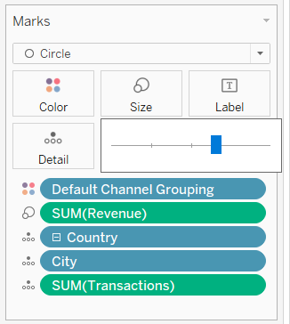

* **Second worksheet:** Revenue per Channel

Drag the dimensions & measures as follows.

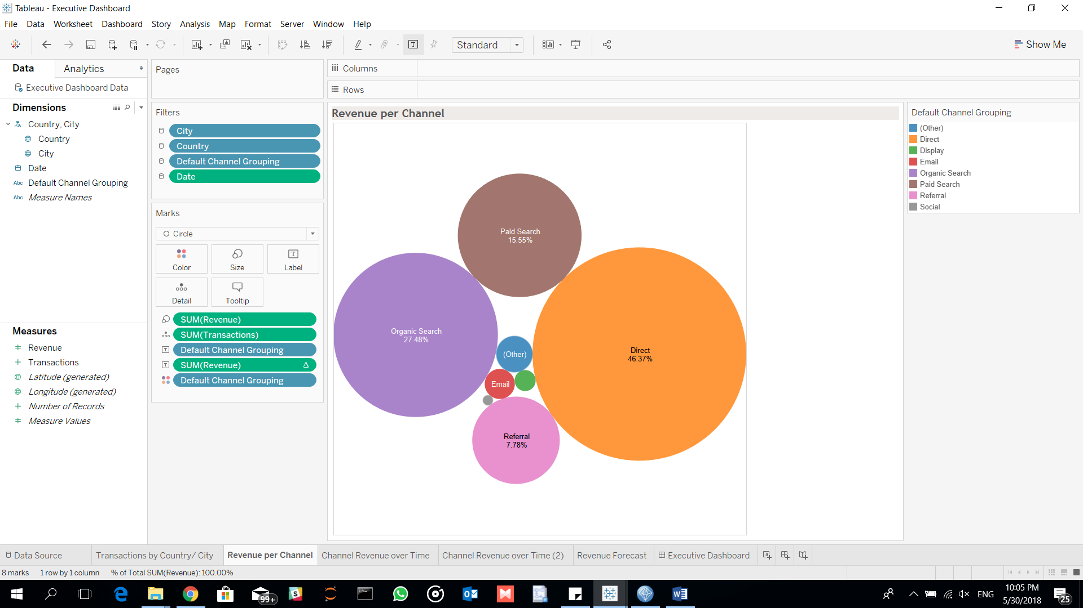

* **Third worksheet:** Channel Revenue over Time (Monthly)

Drag the dimensions & measures as follows.

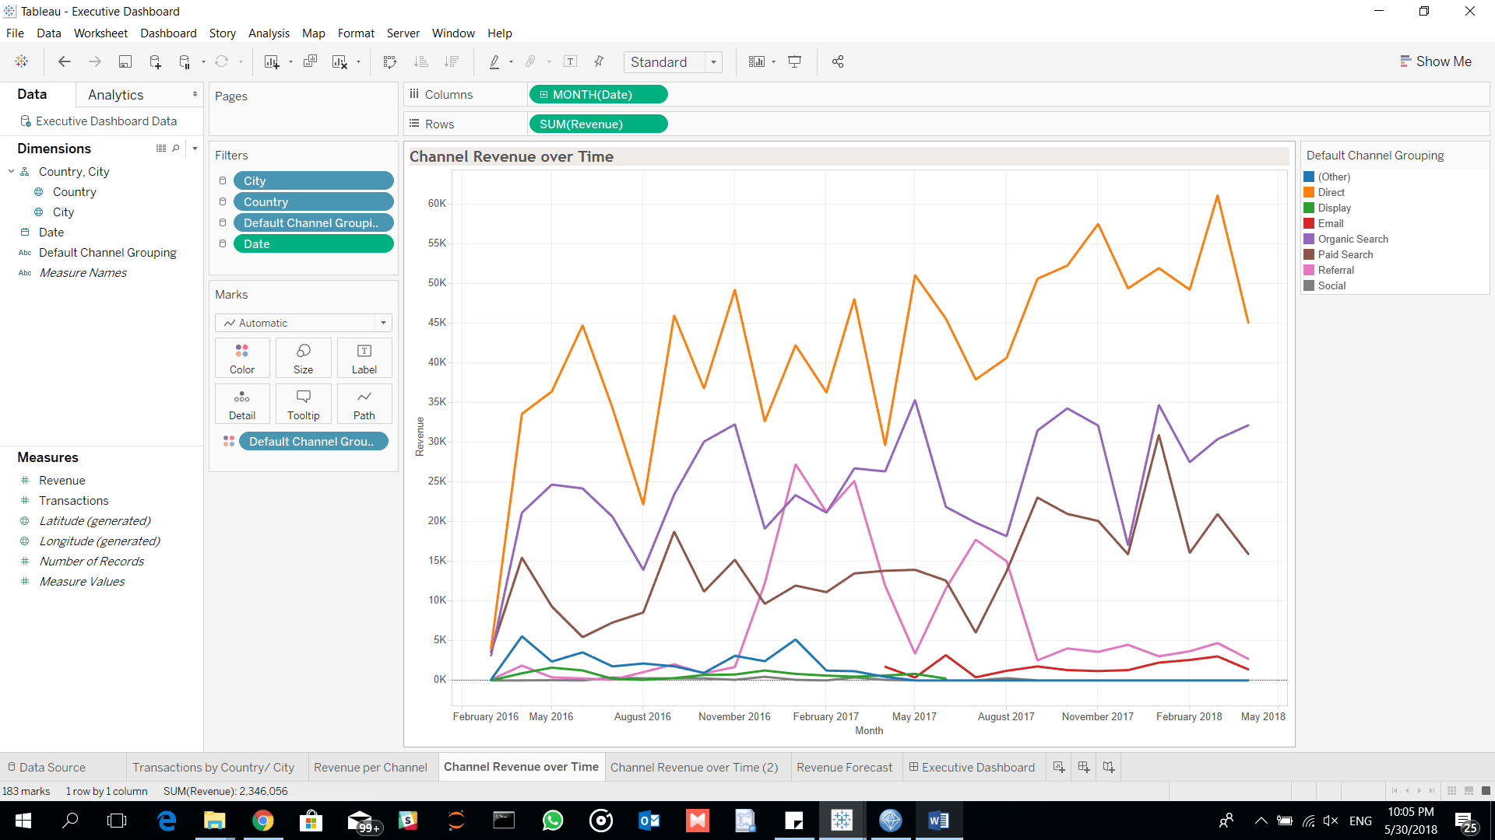

* Hide worksheet title.

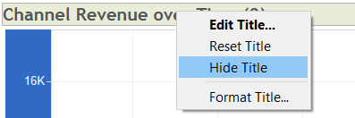

* **Fourth worksheet:** Channel Revenue over Time (Weekly)

Drag the dimensions & measures as follows.

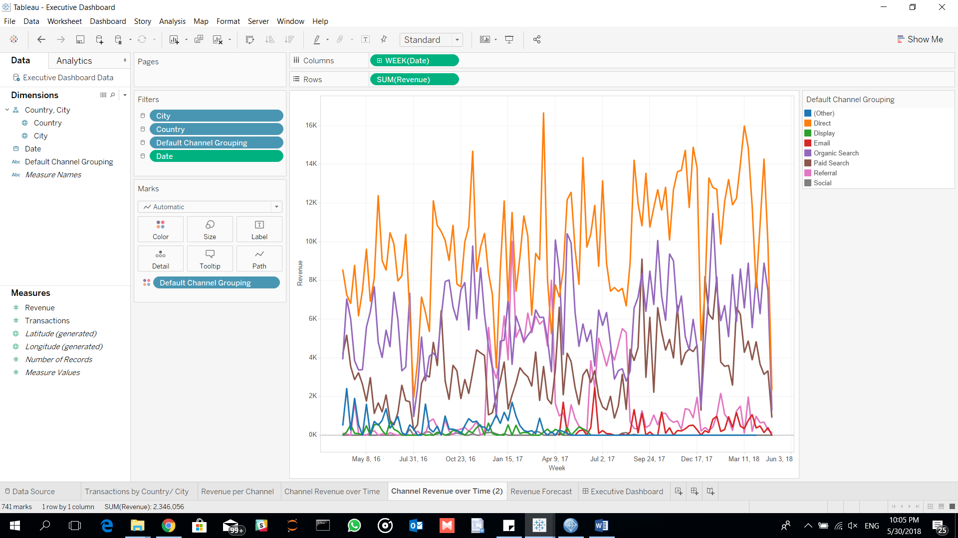

* **Fifth worksheet:** Revenue Forecast

Drag the dimensions & measures as follows.

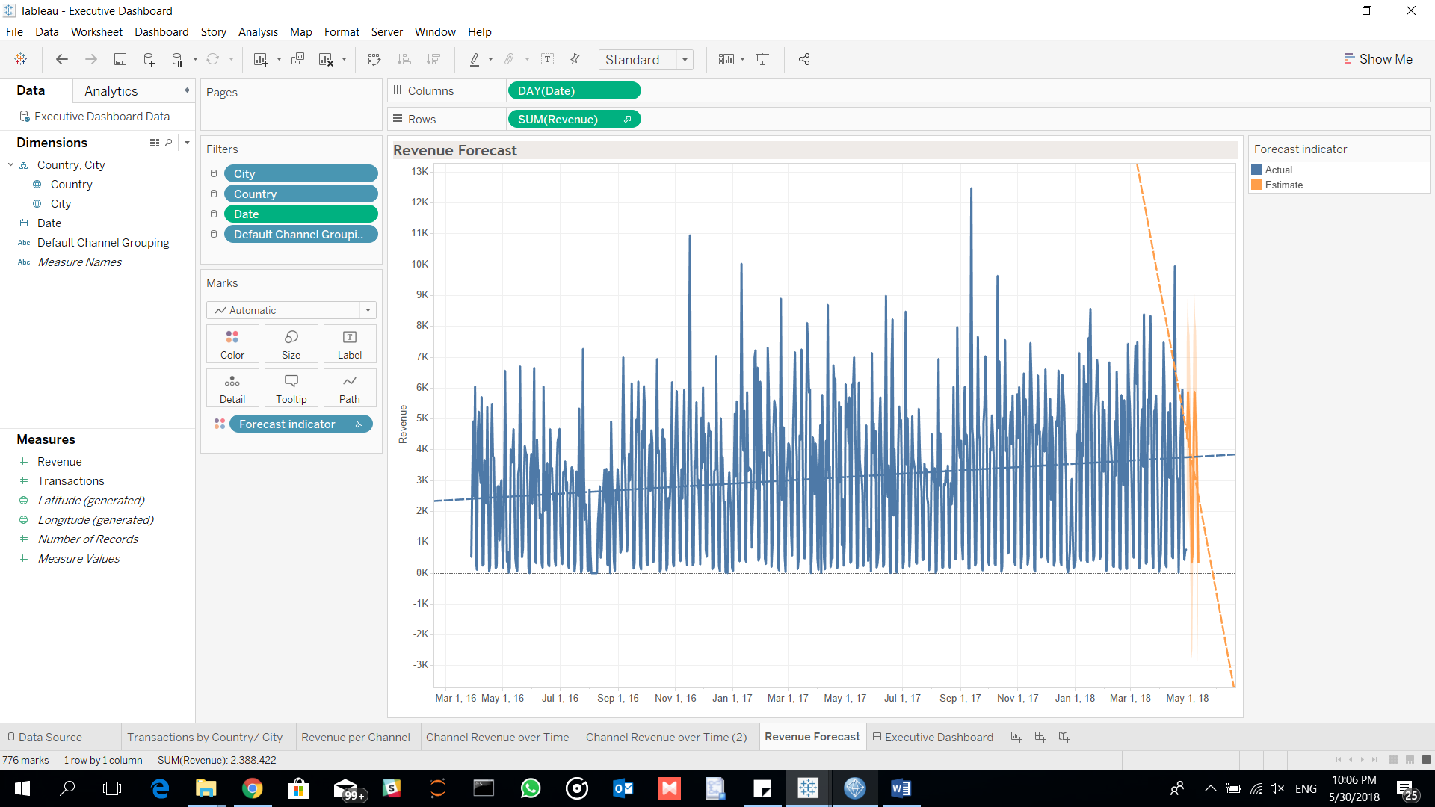

* Select ‘Trend Line’ and ‘Forecast’ in the ‘Analytics’ tab



* Double-click on each worksheet in the Dashboard pane, to add them to the dashboard.
* Show/Hide global filters accordingly.

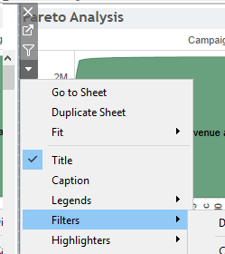

(These steps are common in all dashboards in the report, and will not be repeated in subsequent dashboards. Only key steps will be highlighted from here on.)

#### Campaign Analysis Dashboard

* Dimensions and Measures:

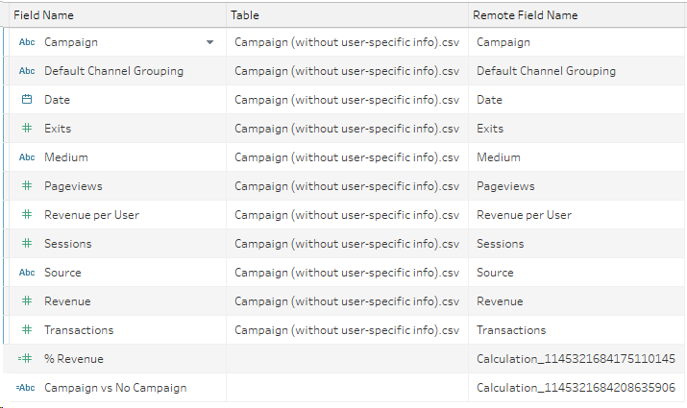

* Calculated fields:

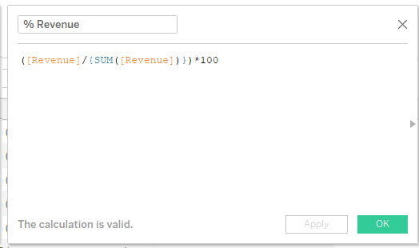

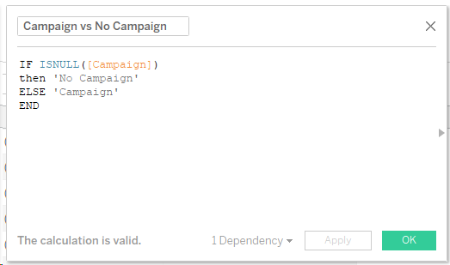

* Overall dashboard:

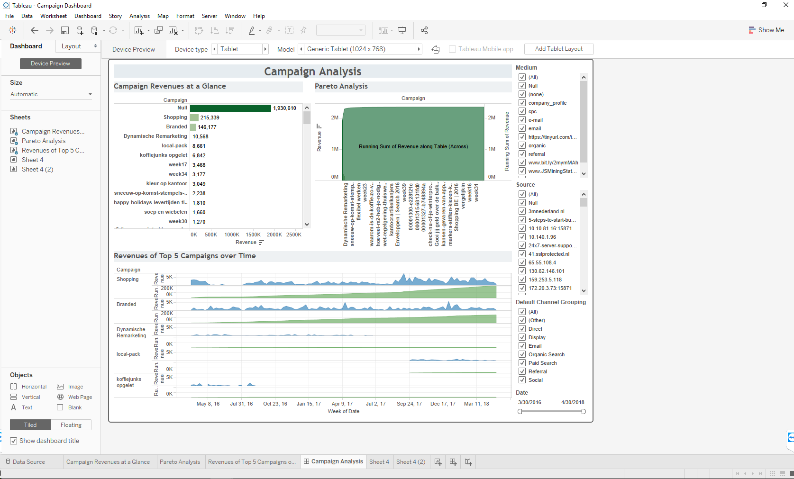

* Sheet 1:

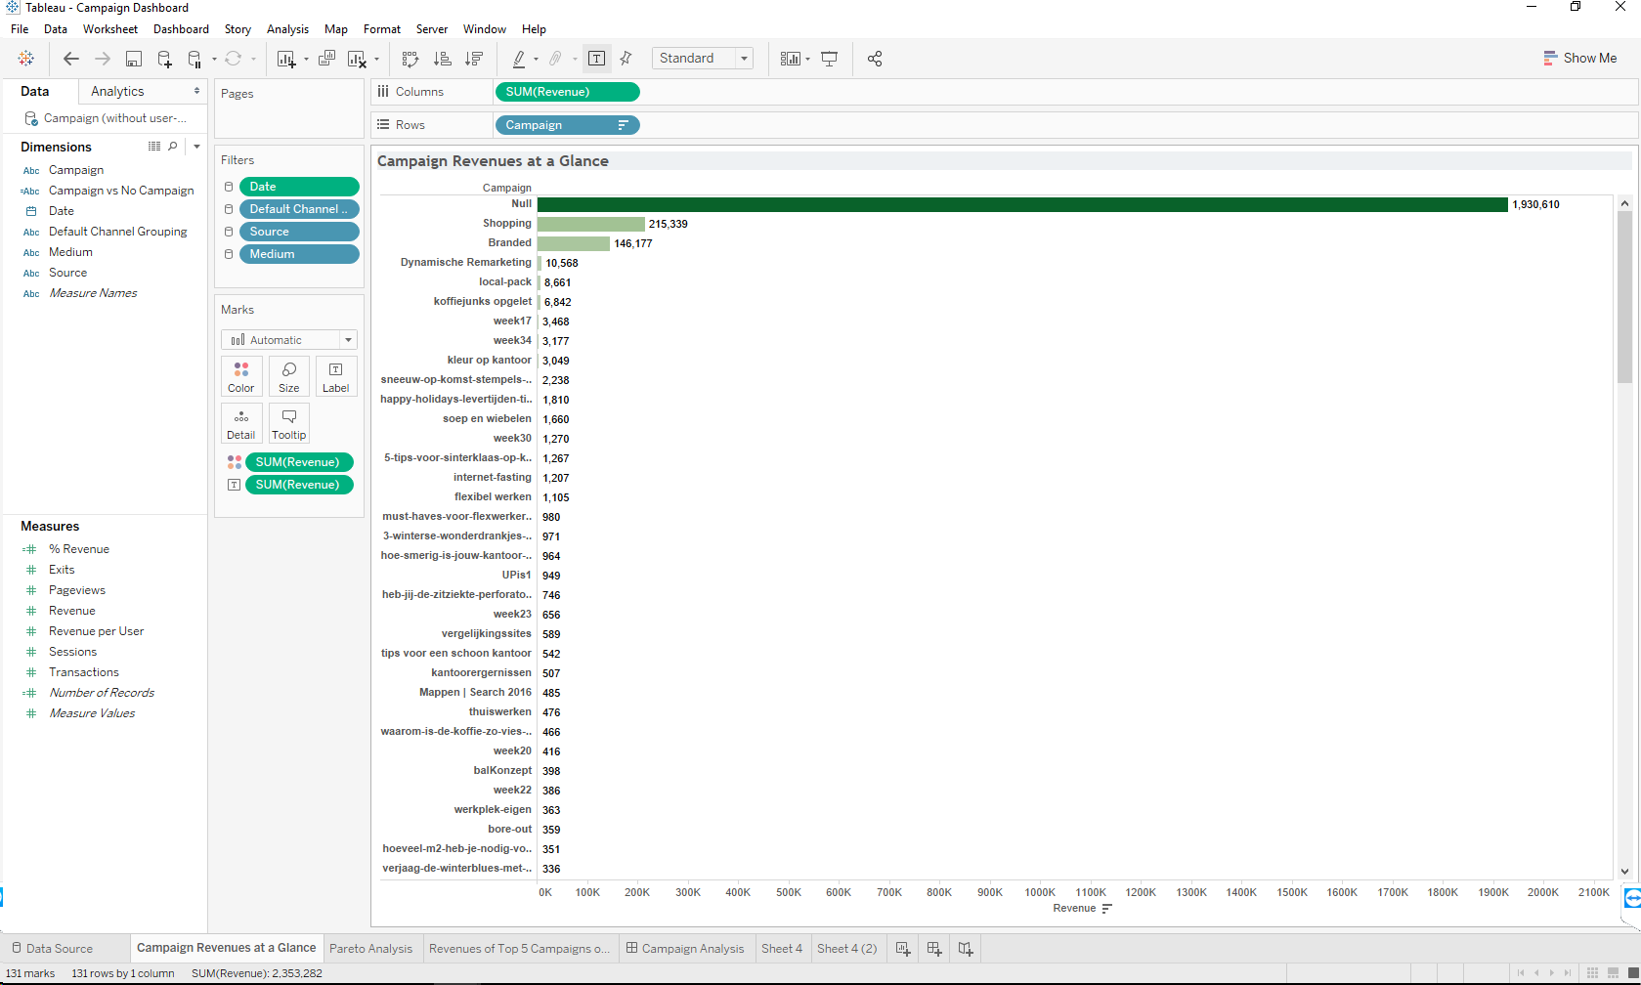

* Sheet 2: Pareto chart

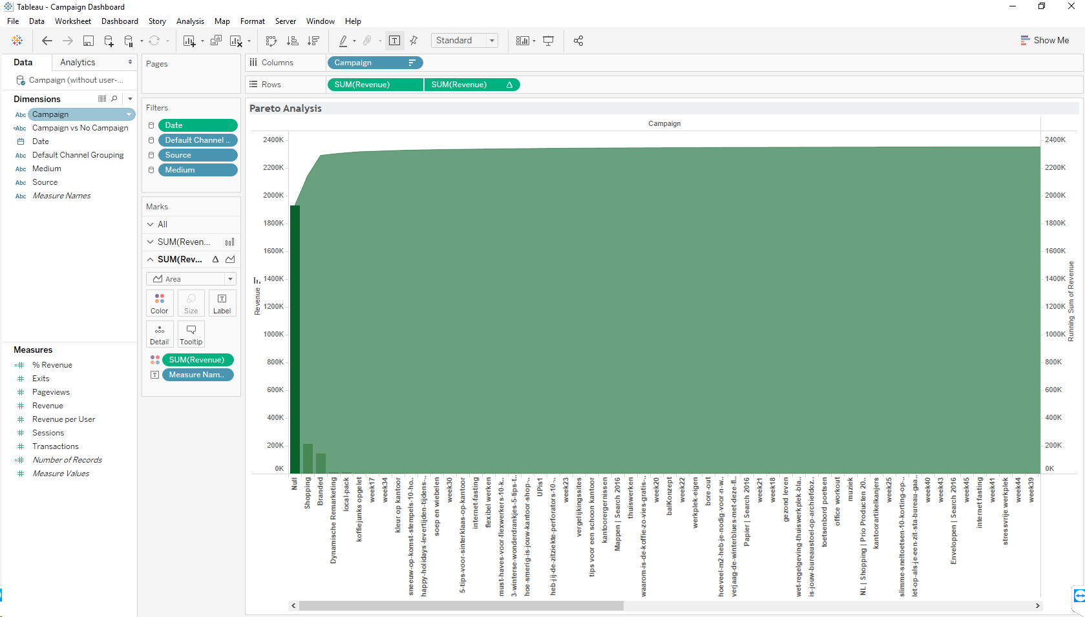

* Dual axis, and running sum:

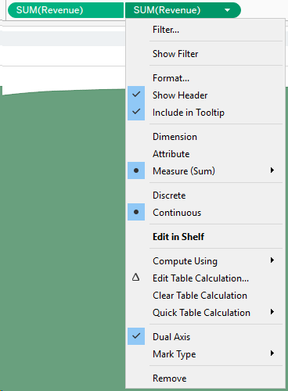 

* Chart types:

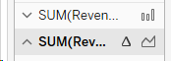

* Sheet 3:

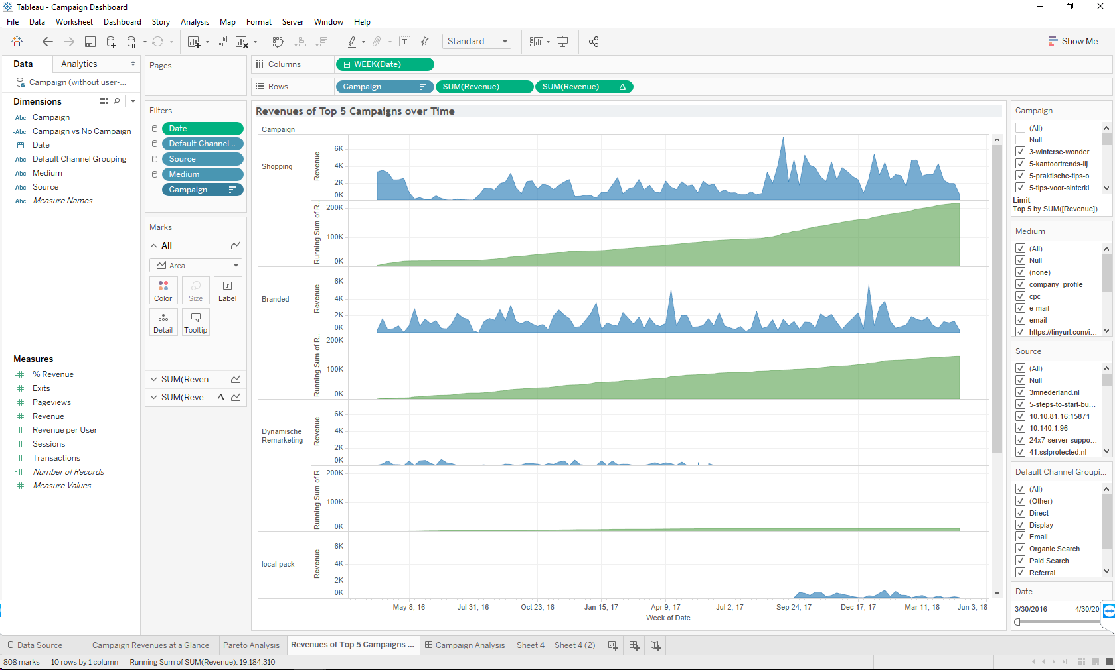

* Add the worksheets to the dashboard.

#### Site Usage Dashboard

To create the Site Usage dashboard, we started by showing the sessions per country.

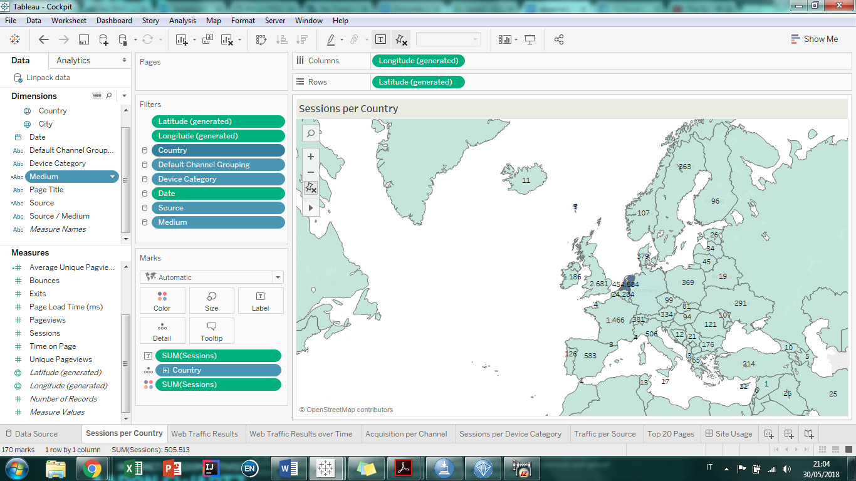

In this worksheet, we employed some calculated fields, such as Medium:

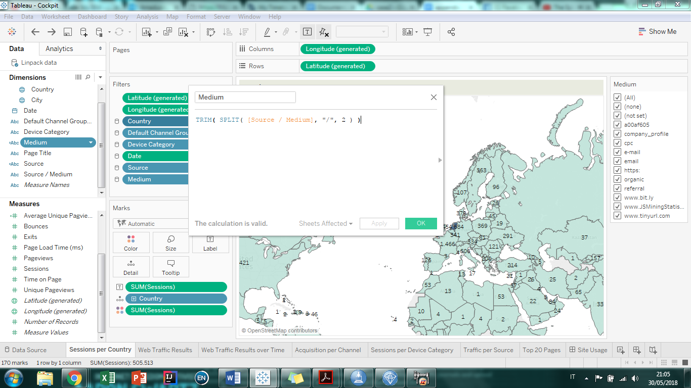

Then we created Source:

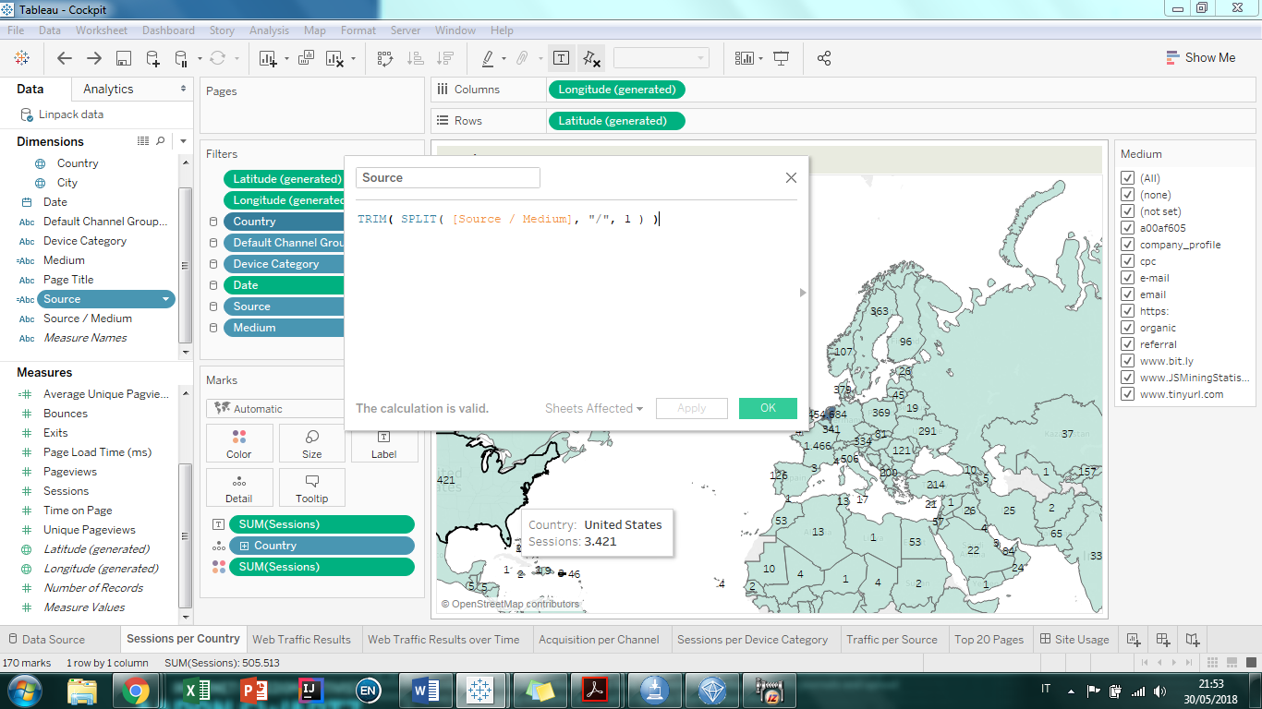

Then we created Average Bounces:

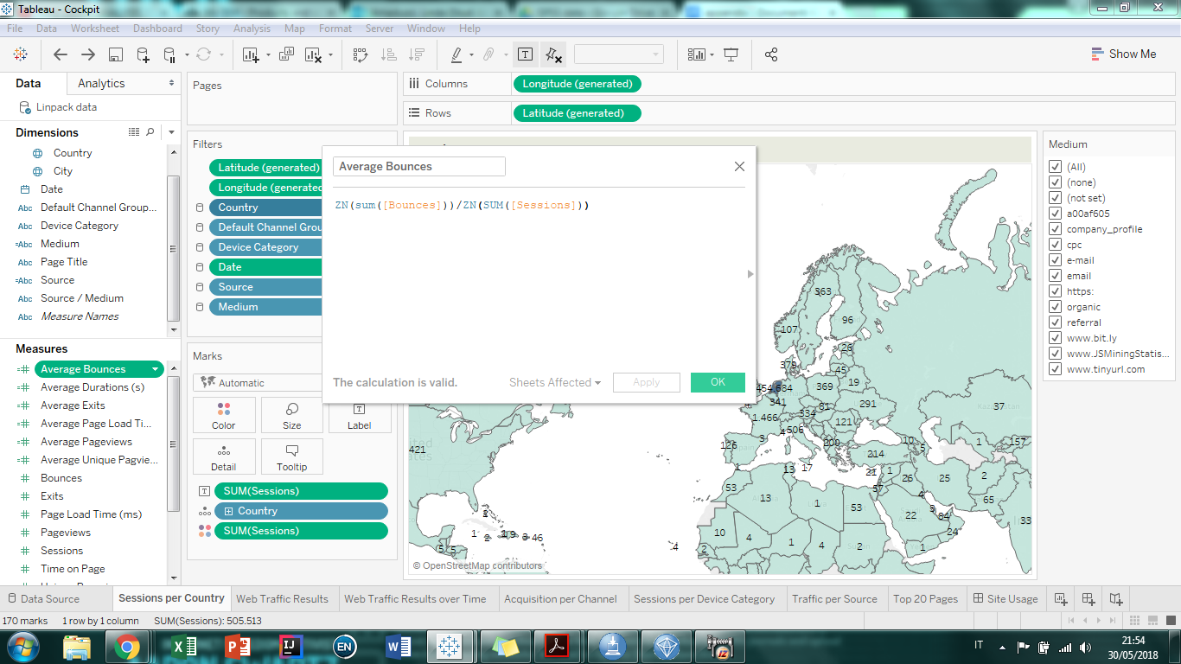

Then we created Average Duration:

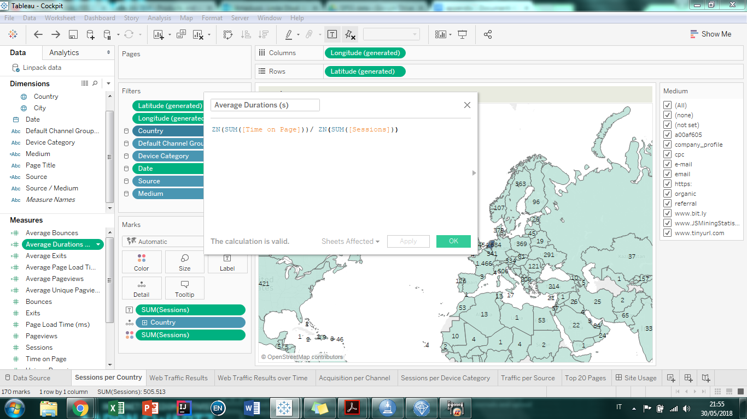

Then we created Average Exits:

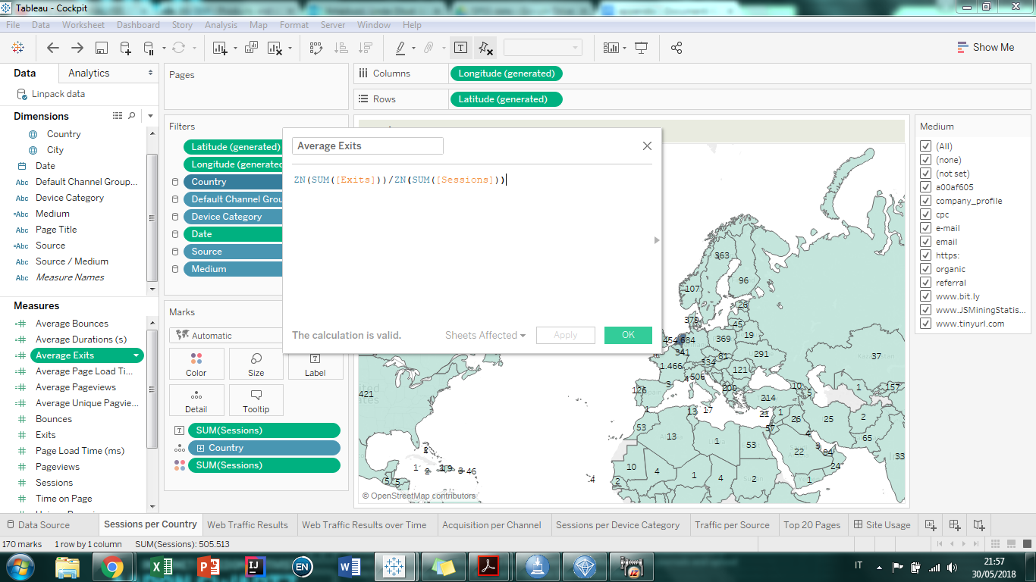

Then we created Average Page Load Time:

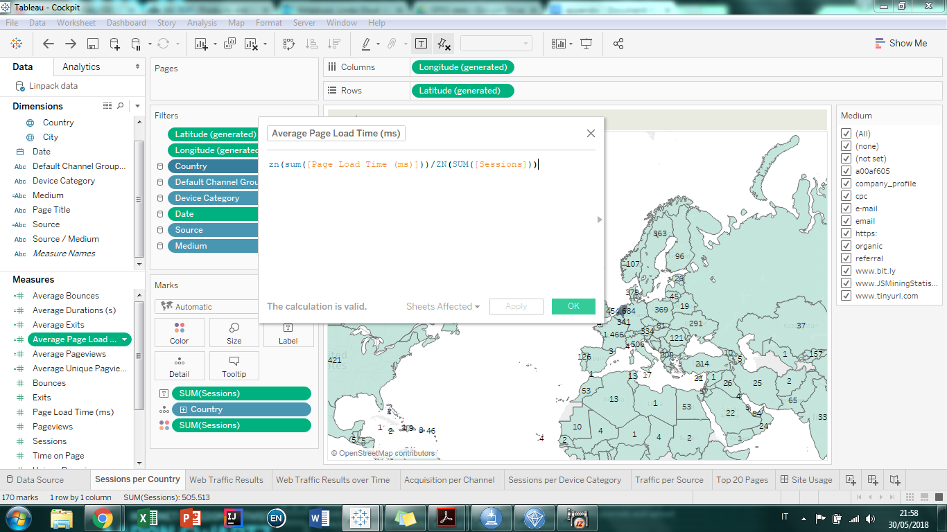

Then we created Average Pageviews:

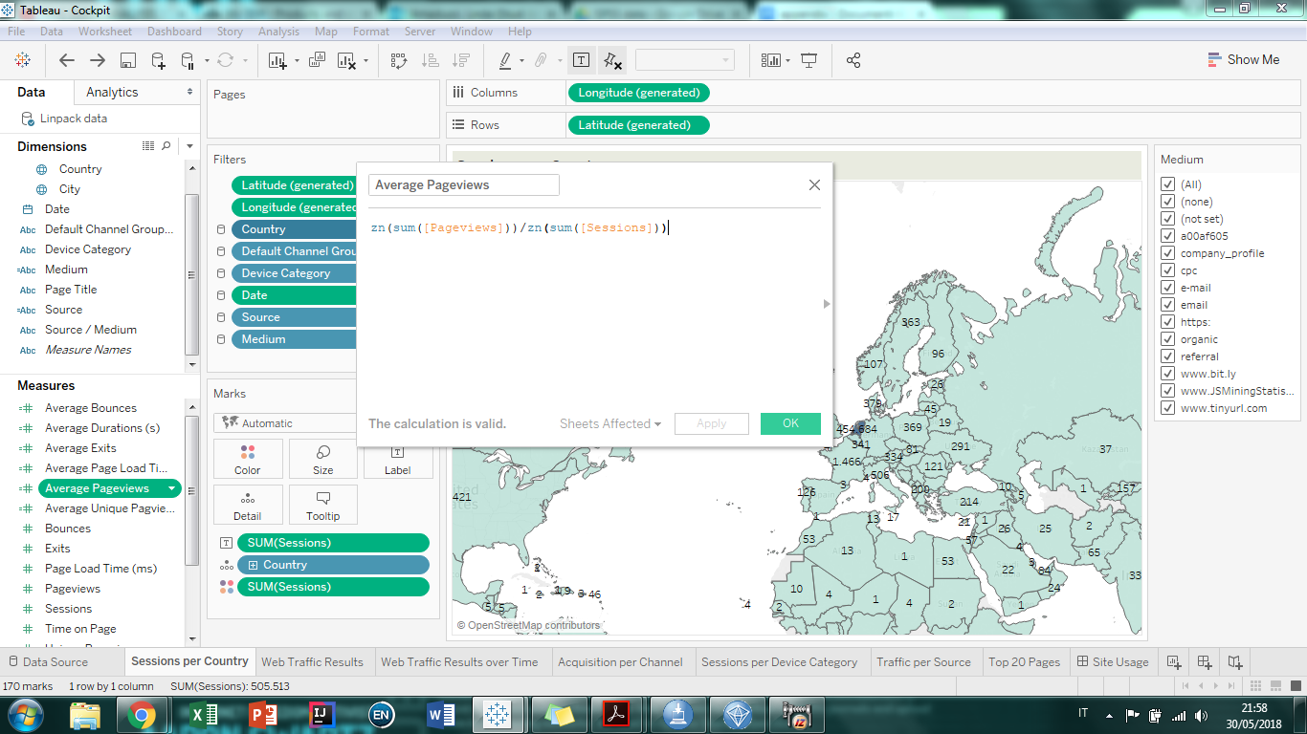

Then we created Average Unique Pageviews:

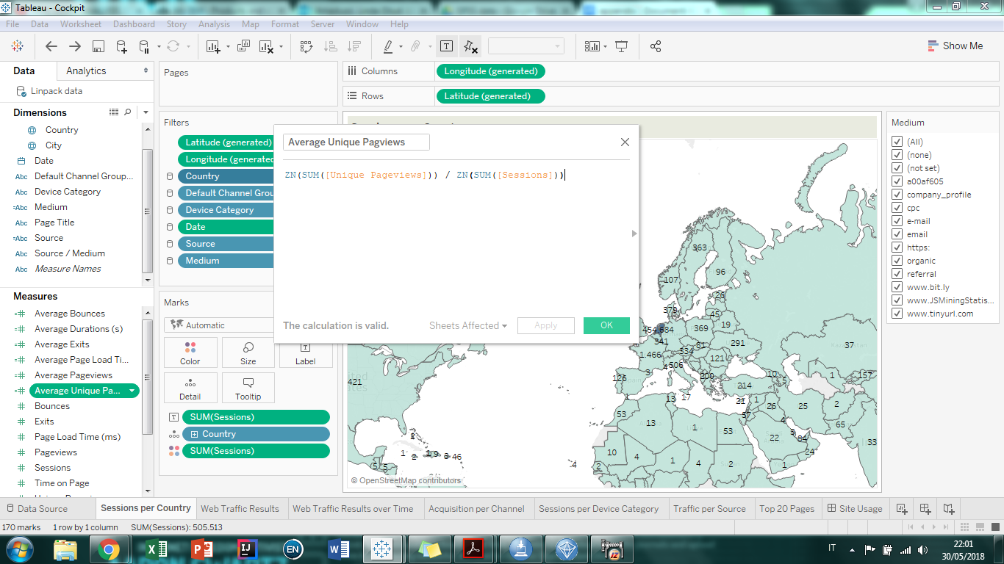

We applied some filters to the whole dataset:

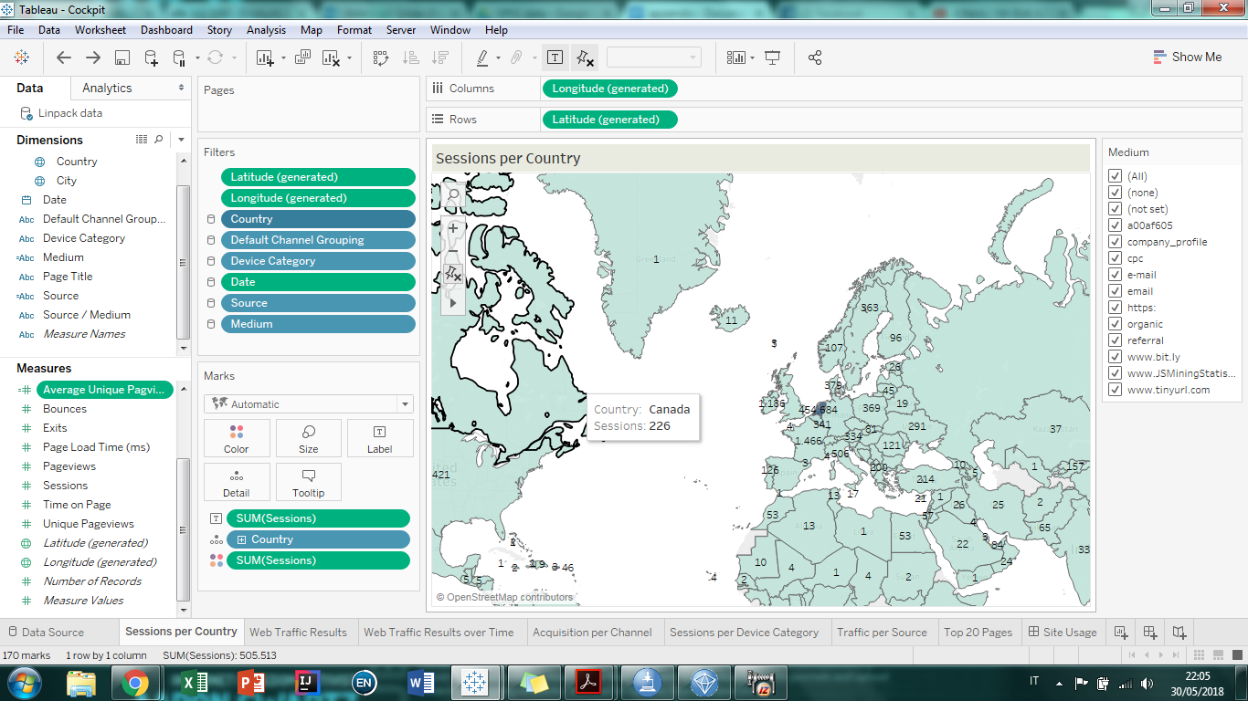

and then we created the first worksheet by arranging the dimensions and measure as displayed in the picture:

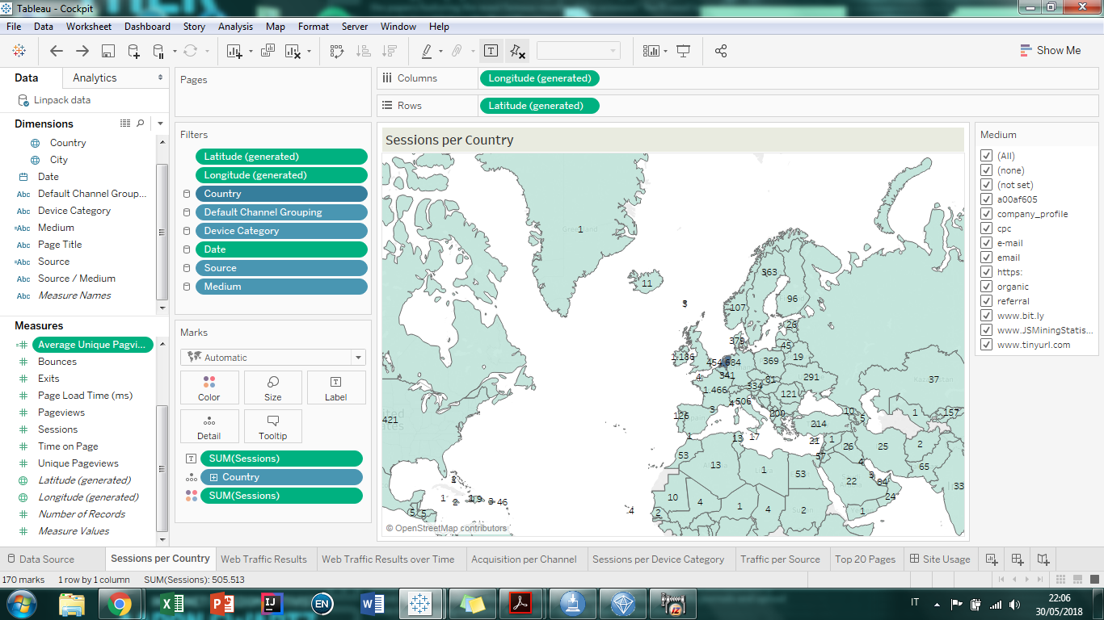

Then we proceeded to create the second worksheet, Web Traffic Results by arranging the dimensions and measures as shown in the picture:

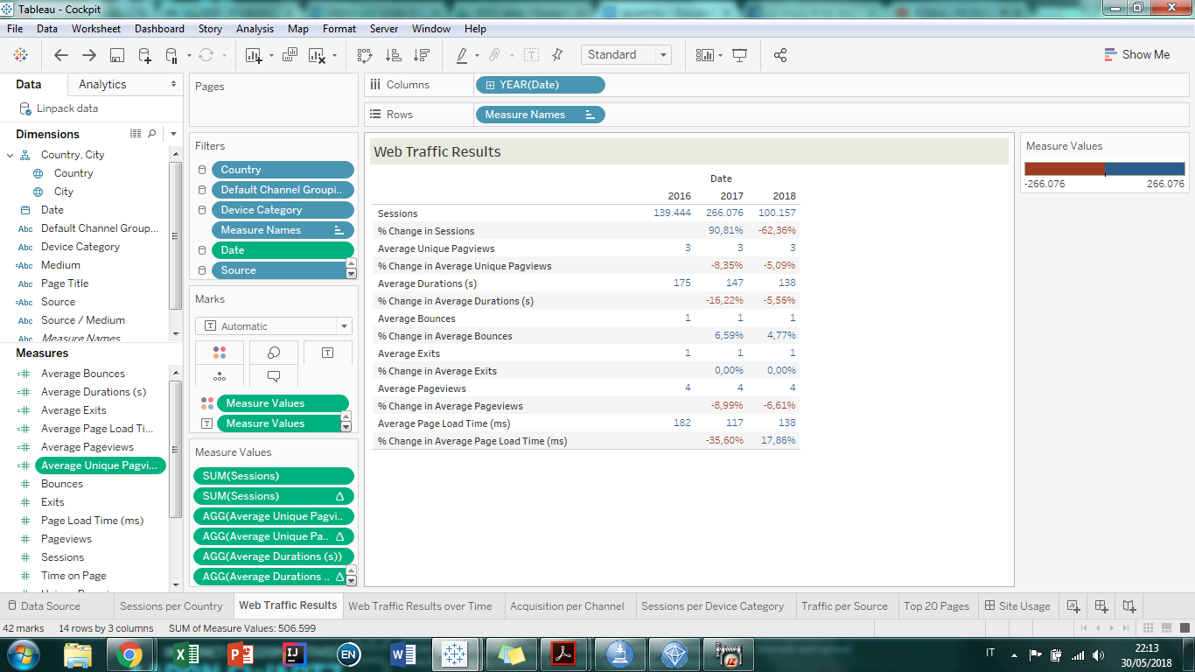

Then we proceeded to the Traffic Results Over Time, arranging the dimensions and measures as shown in the picture:

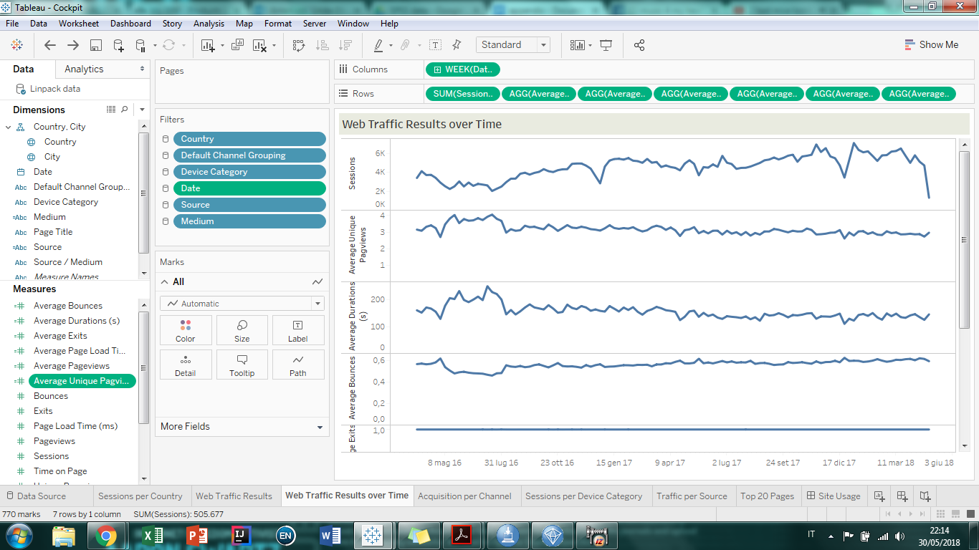

Then we created the Aquisition Per Channel worksheet, by arranging dimensions and measures as shown in the picture:

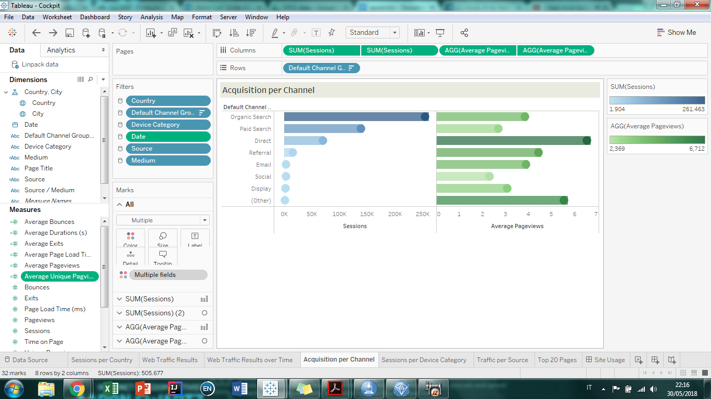

Then we proceeded to the Sessions Per Device Cathegory, by arranging dimensions and measure as shown in the picture:

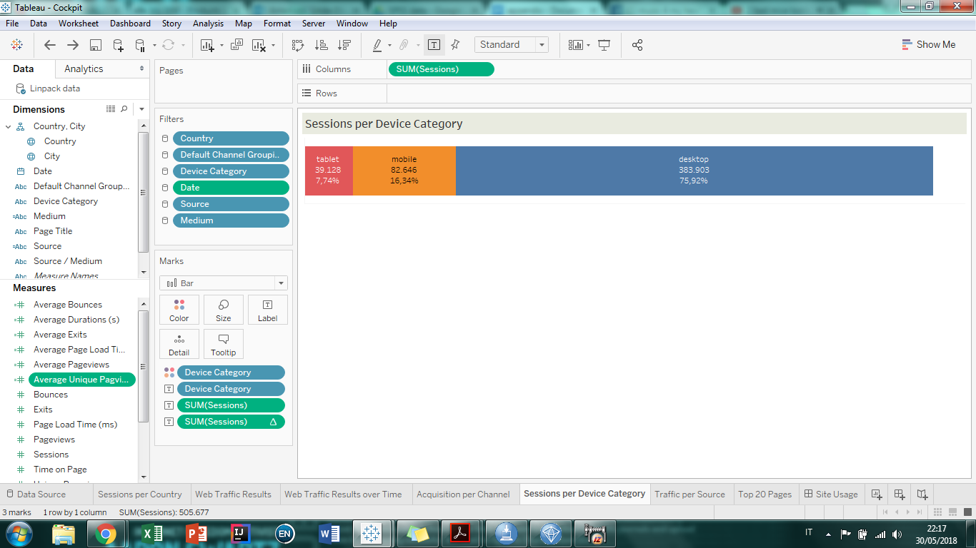

Then we created the Traffic per Source worksheet by aranging the measures and dimensions as shown in the picture:

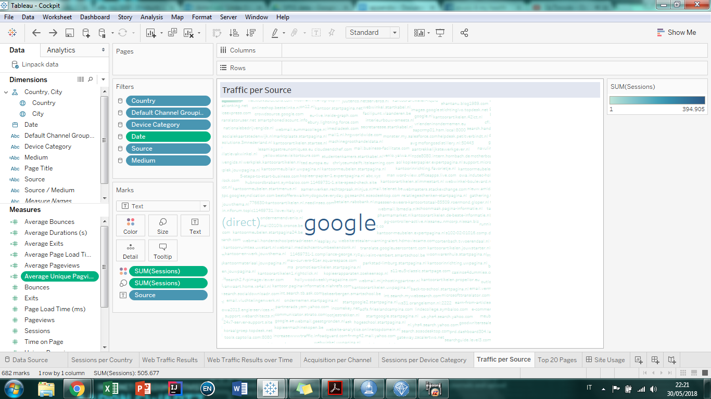

Then we created the Top 20 pages worksheet by arranging measures and dimensions as show in the picture:

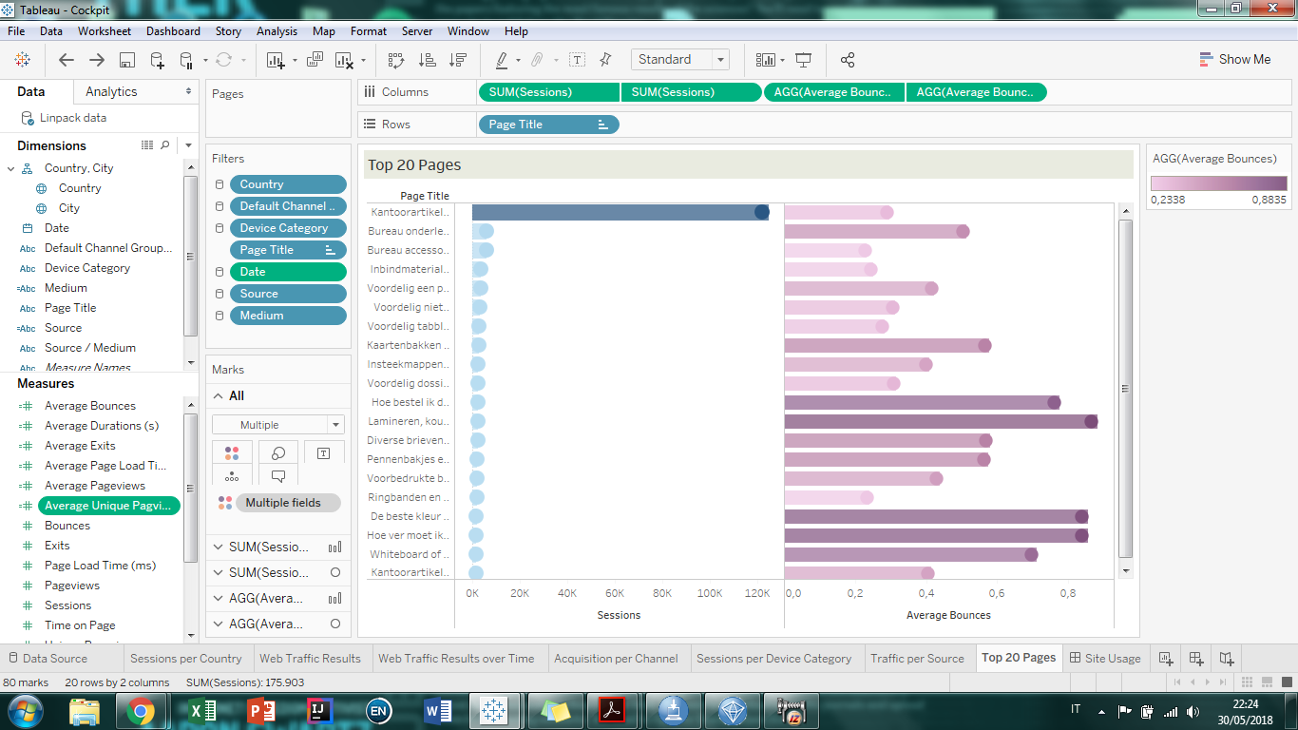

### SPSS Modeler

#### Campaign Analysis

Product Stream:

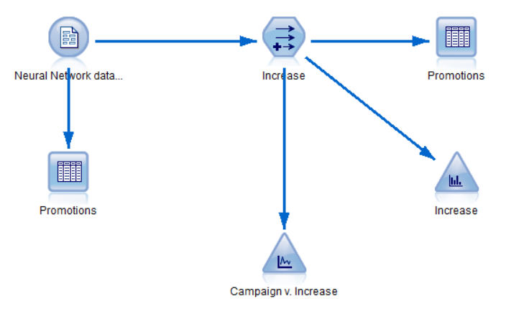

Model Stream:

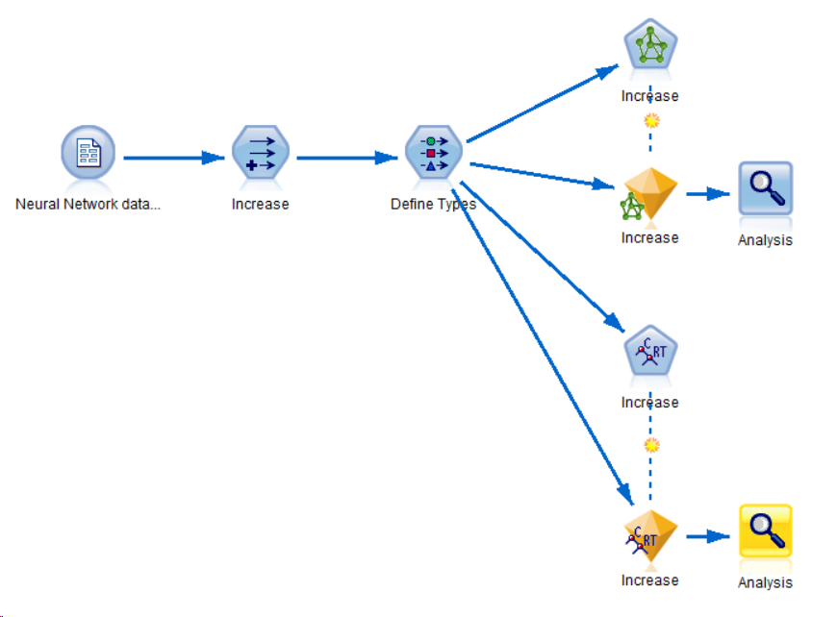

Data types:

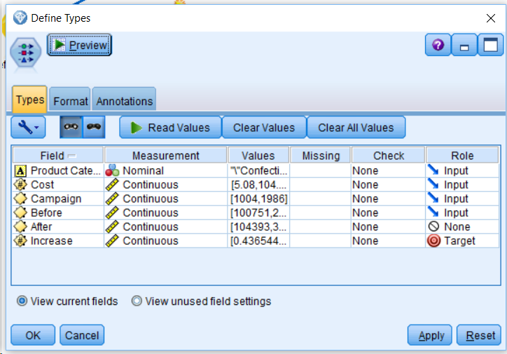

Model Result:

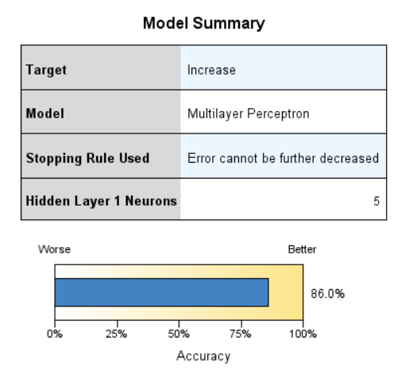

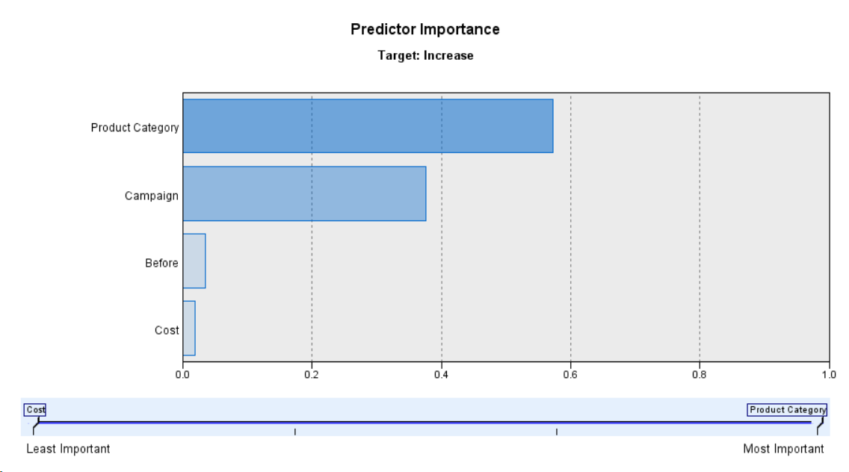

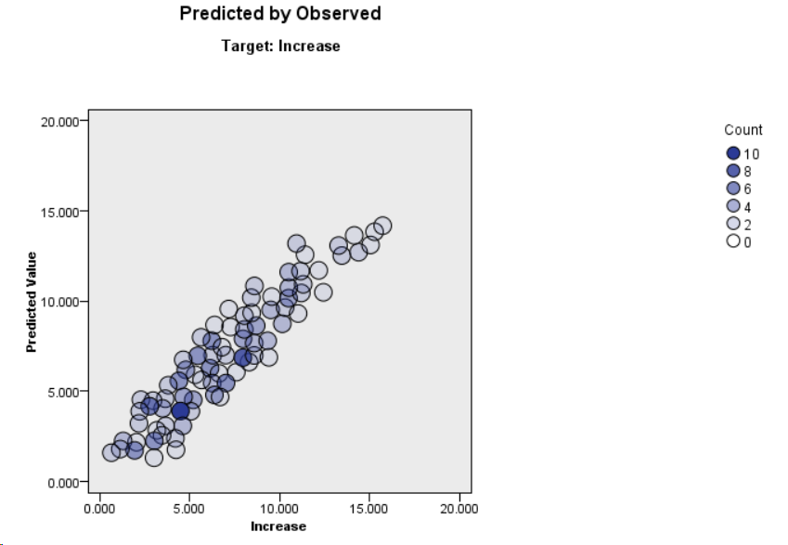

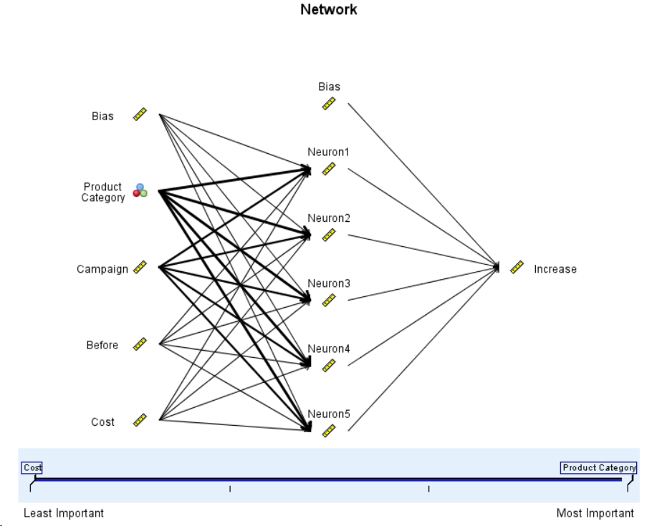

#### Revenue Prediction

Stream:

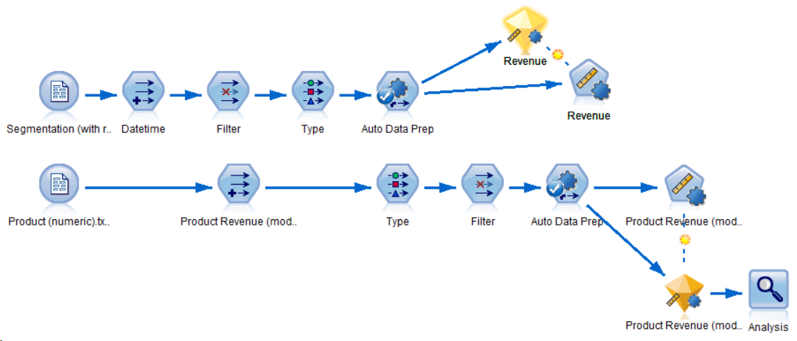

Format the ‘Date’ variable using the Derive node, and thus get a new variable called ‘Datetime’:

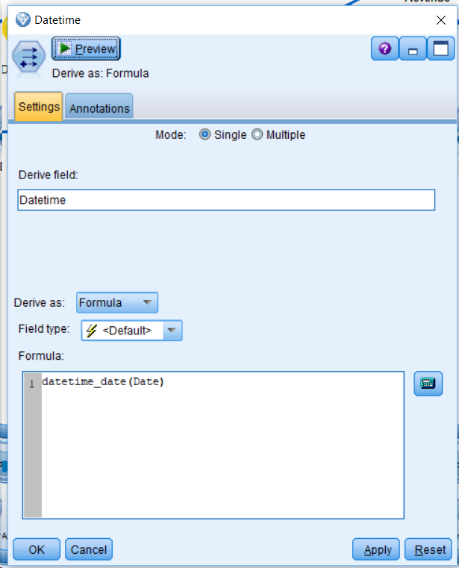

Filter out the original ‘Date variable:

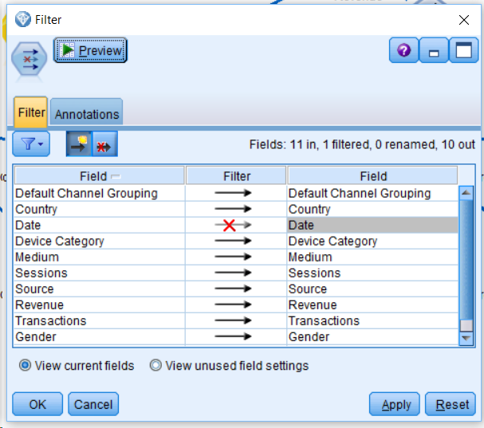

Data types (for upper line);

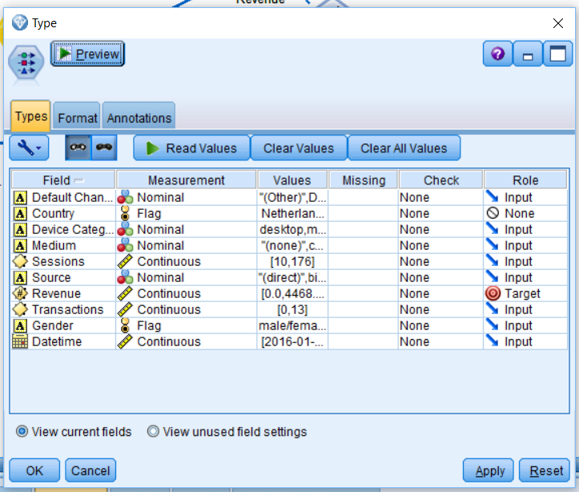

Convert product revenue from string to number:

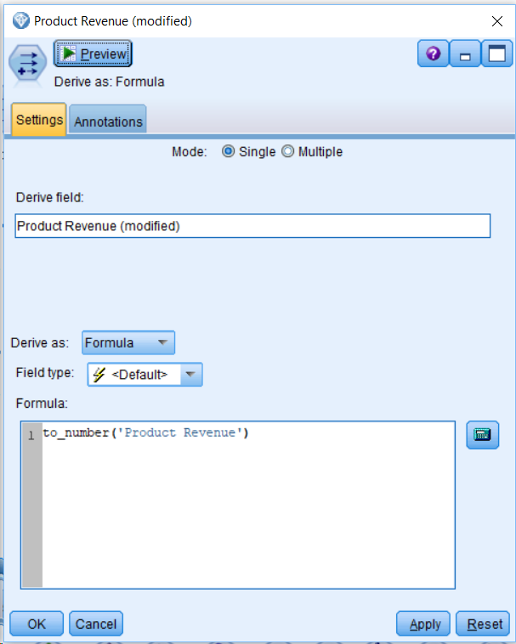

Filter out the old ‘Product Revenue’ variable:

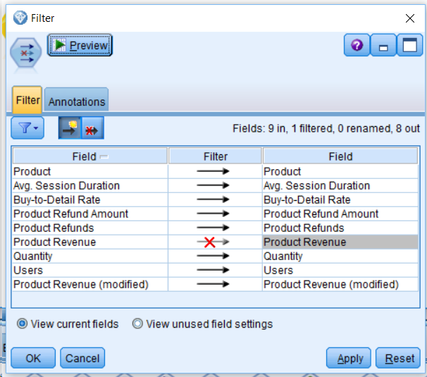

Data types for lower line:

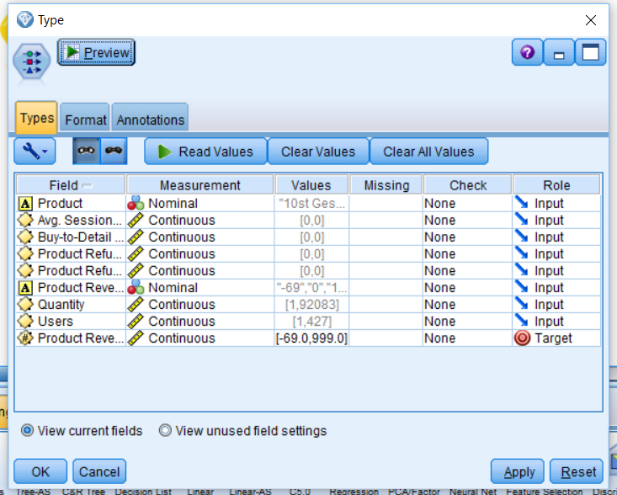

### Additional Tableau Figures

#### Key Performance Indicator per City Overview

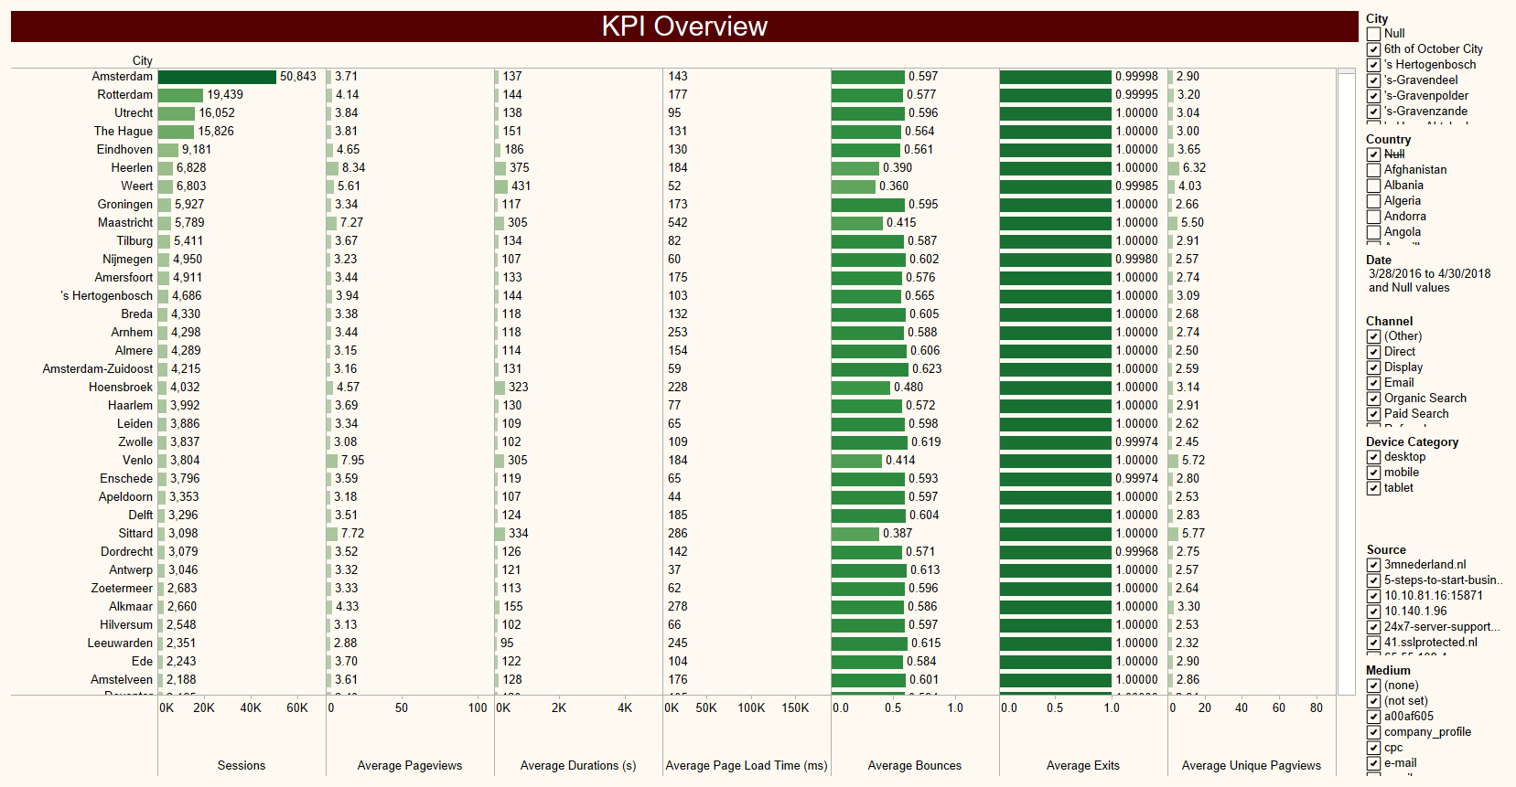

Figure 15 KPI Overview

The chart shows the performance of the website in the different cities. Amsterdam shows to be the best performing city,

#### Acquisition

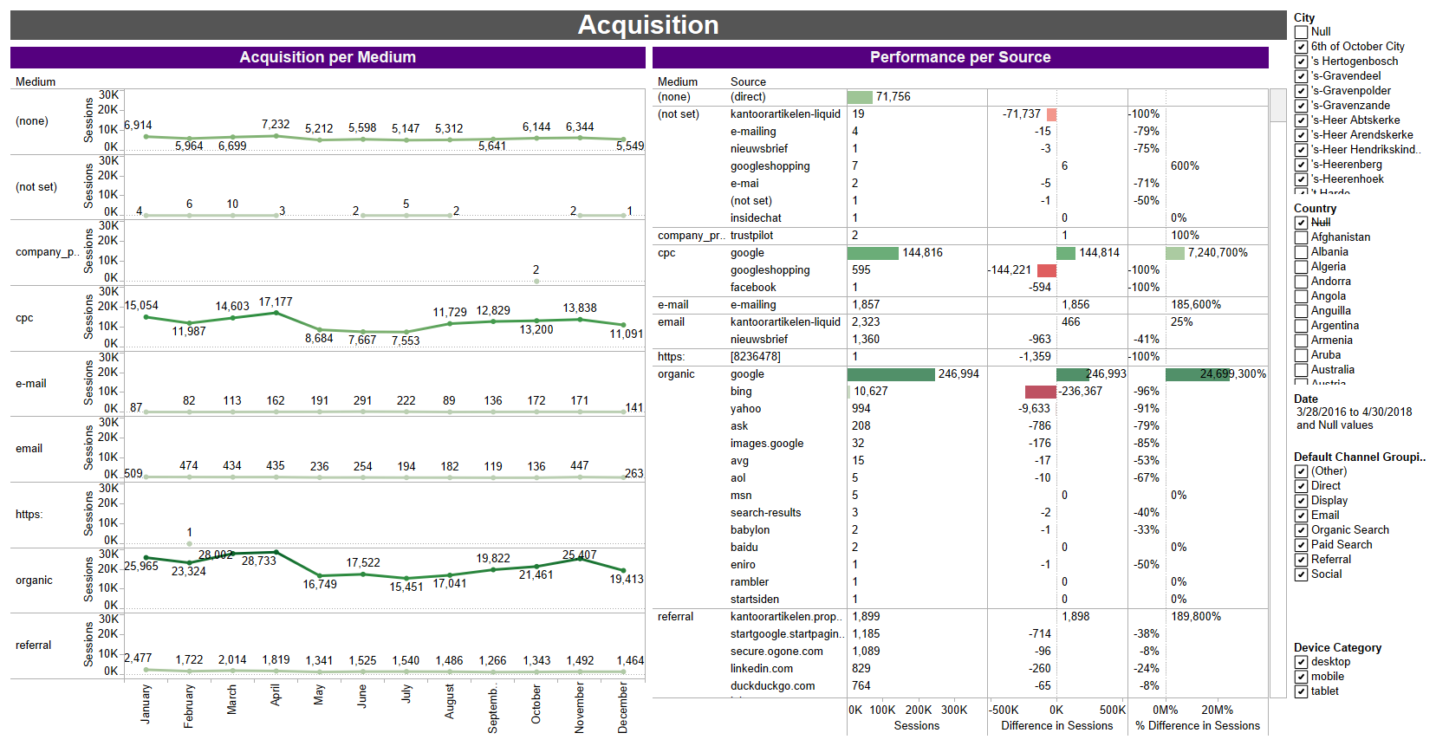

Figure 16 Acquisition Dashboard

From the dashboard, we can see that the acquisition of direct searches stay relatively stable ( $\sim$ 6000 sessions) throughout the entire period, whereas those of organic and CPC (or cost-per-click) searches declined after April, only to increase slowly but steadily from July onwards. By identifying the most popular ways by which users access the website, further campaigns could better cater to such media.

#### Segmentation

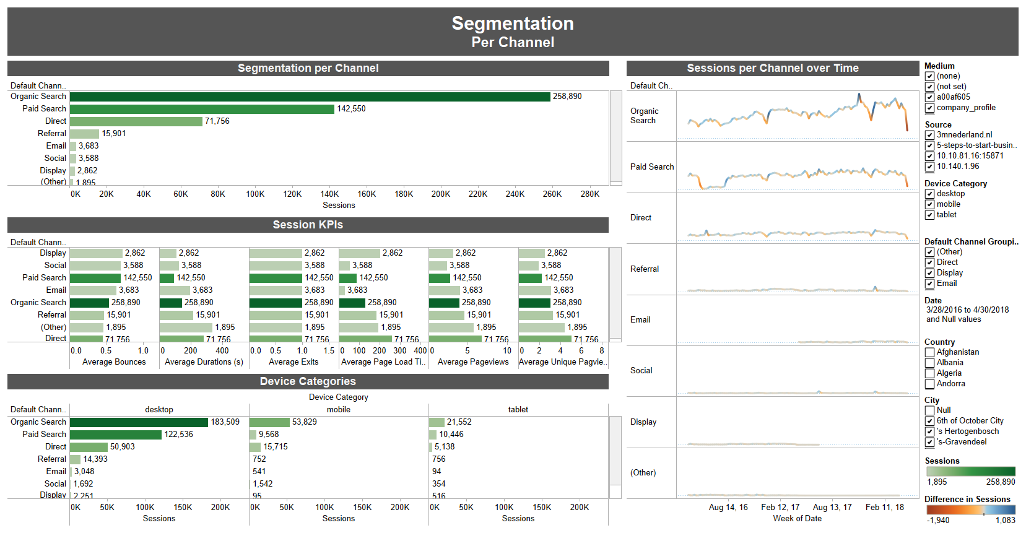

Figure 17 Segmentation Dashboard

#### Trend Analysis

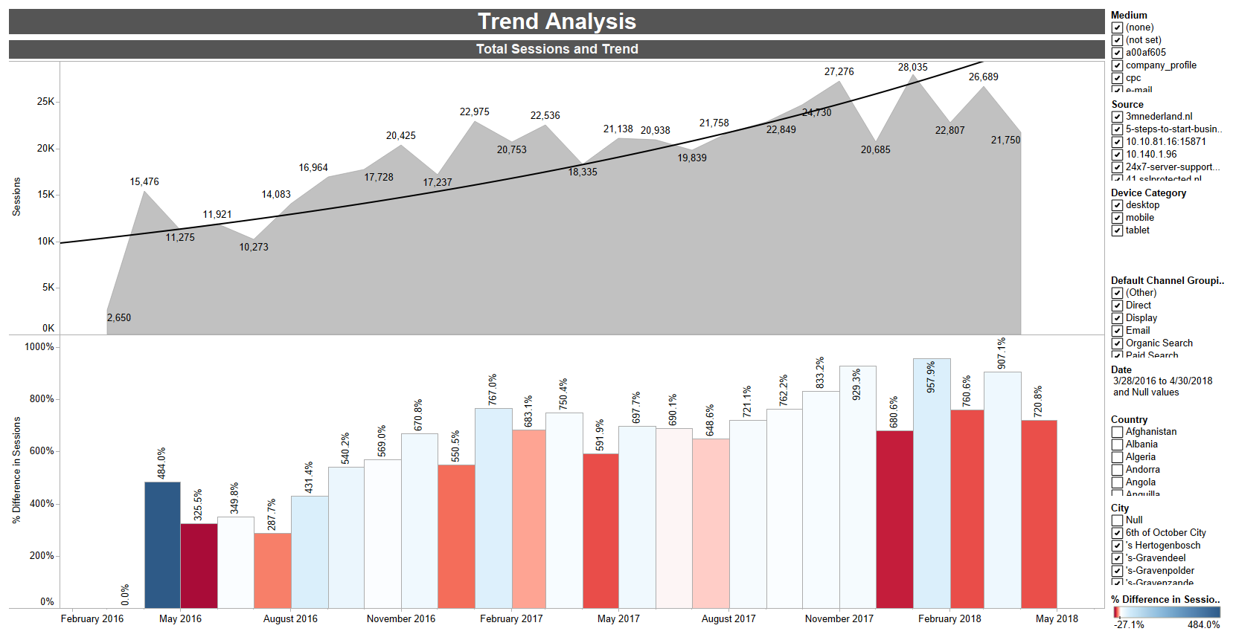

Figure 18 Trend Analysis Dashboard

#### Pareto Analysis on Session Durations

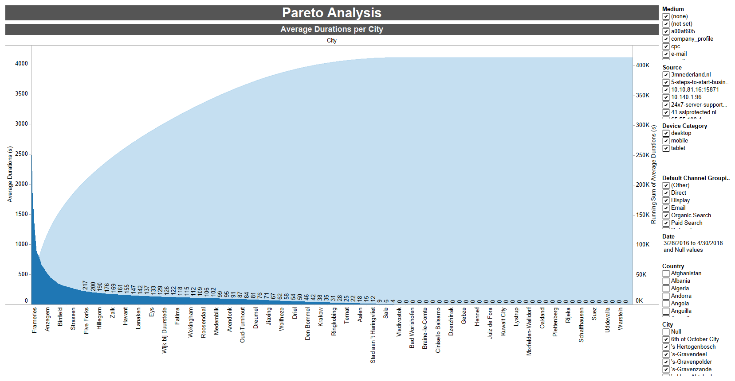

Figure 19 Pareto Analysis Dashboard

1. Google Analytics. (2018, May 28). Retrieved May 30, 2018, from https://en.wikipedia.org/wiki/Google_Analytics
2. Direct traffic usually refers to traffic from sources such as bookmarks, favorites, saved browser history, or direct URL iteration into the browser.
3. Organic search is a method for entering one or several search terms as a single string of text into a search engine.
4. Megalytic.com. (2015). Understanding Direct Traffic in Google Analytics | Megalytic Blog. [online] Retrieved May 30, 2018, from https://megalytic.com/blog/understanding-direct-traffic-in-google-analytics.
5. Haughey, D. (2018). *Pareto Analysis Step by Step*. [online] Project Smart. Available at: https://www.projectsmart.co.uk/pareto-analysis-step-by-step.php [Accessed 30 May 2018].
6. Bass, F. M., & Clarke, D. G. (1972). Testing distributed lag models of advertising effect. *Journal of Marketing Research*, 298-308.
7. Distributed lag. (2018, March 04). Retrieved May 30, 2018, from https://en.wikipedia.org/wiki/Distributed_lag
8. Dhalla, N. K. (1978). ASSESSING LONG-TERM VALUE OF ADVERTISING. *Harvard Business Review*, *56*(1), 87-95.
9. ibid.
10. IBM Knowledge Center. (n.d.). Retrieved May 30, 2018, from https://www.ibm.com/support/knowledgecenter/de/SS3RA7_15.0.0/com.ibm.spss.modeler.help/neuralnet_model.htm
11. Burke, H. B., Rosen, D. B., & Goodman, P. H. (1995). Comparing the prediction accuracy of artificial neural networks and other statistical models for breast cancer survival. In *Advances in neural information processing systems* (pp. 1063-1067).
12. The original implementation of the Neural Net model in SPSS Modeler on this fictitious dataset can be referred to in the IBM SPSS Modeler 18.0 Applications Guide.